**LEAVESHERO:**

**AN APPLICATION FOR EMPLOYEE LEAVES MANAGEMENT**

A Proposal

Presented to the Faculty of the

College of Computer Studies, University of Cebu

In Partial Fulfilment of the Requirements

for the degree Bachelor of Science in Information Technology

By

John Lawrence B. Briones

Ailen M. Manalili

Shaira Mae Romeo

Mr. Joaquin Patiño

Adviser

October 2018

# ACKNOWLEDGEMENT

This work is not possible without the help and support of many individuals. We would like to extend our deepest gratitude to them.

Foremost, we would like to God Almighty for the guidance and blessings. For the wisdom, peace of mine, good health and strong courage to fulfill our dreams and to finish this research.

We also extend our gratitude to our family for encouraging us to study hard, for understanding us, for supporting us financially, and for giving us moral support to complete this research.

We also acknowledge our friends who are always there helping us to come up to this idea, for cheering us, for giving us the courage to pursue and for sharing their knowledge and skills to help our research.

To our kind-hearted adviser, **Mr. Joaquin Patiño**, we are really grateful to have you. Thank you for sharing your ideas about our research, for your guidance and advice.

A special gratitude to our beloved dean, **Dr. Melvin Niñal**, for suggesting this research idea to our team.

# DEDICATION

This research is dedicated to our beloved family who continually provides their moral, emotional, and financial support, for being the source of our inspiration and courage to complete this research.

We also dedicate this research to our friends who give their nonstop support to us.

To God Almighty who guides us with his grace, who bless us and give us the courage to face the problem we encounter as a team.

Foremost, we dedicate this research to all employees who work hard for their family, and to all companies who count their employees’ hard work.

# TABLE OF CONTENTS

ACKNOWLEDGEMENT ii

DEDICATION iii

TABLE OF CONTENTS iv

LIST OF TABLES vi

CHAPTER I: INTRODUCTION 1

Rationale of the Study 1

Objectives of the Study 3

Scope and Limitations of the Study 4

Significance of the Study 5

Flow of the Study 6

Definition of Terms 7

CHAPTER II: REVIEW OF RELATED LITERATURE AND STUDIES 8

Related Literature 8

Related Studies 11

Comparative Matrix 14

CHAPTER III: RESEARCH METHODOLOGY 16

Software Engineering Methodology 16

Planning/Conception-Initiation Phase 17

Business Model Canvas 17

Program Workflow 18

Validation Board 19

Gantt Chart 21

Functional Decomposition Diagram 22

Analysis-Design Phase 24

Use Case Diagram 24

Storyboard 26

Database Design 43

Network Design 50

Technology Stack Diagram 52

Program Specification 54

REFERENCES 57

CURRICULUM VITAE 58

APPENDICES 61

# LIST OF TABLES

Table 1 COMPARATIVE MATRIX: WEB SPECIFIC FEATURES 14

Table 2 COMPARATIVE MATRIX: MOBILE SPECIFIC FEATURES 15

Table 3 GANTT CHART 21

Table 4 SUBSCRIPTION 45

Table 5 FEEDBACK 45

Table 6 COMPANY 45

Table 7 DEPARTMENT 46

Table 8 PAYMENT 46

Table 9 EMPLOYEE 46

Table 10 LEAVE REQUEST STATUS 47

Table 11 STATUS INFORMATION 47

Table 12 LEAVE TYPE 47

Table 13 LEAVE REQUEST 48

Table 14 LEAVE REQUIREMENTS 48

Table 15 LEAVE DATE 49

Table 16 POSITION 49

Table 17 APPROVER 49

Table 18 CALENDAR 49

Table 19 LEAVE DURATION 49

Table 20 HISTORY 50

Table 21 REPORT 50

Table 22 NOTIFICATION 50

Table 23 DEVELOPMENT FOR WEB APPLICATION 53

Table 24 DEVELOPMENT FOR MOBILE APPLICATION 53

Table 25 DEPLOYMENT FOR WEB APPLICATION 53

Table 26 DEPLOYMENT FOR MOBILE APPLICATION 53

Table 27 HARDWARE DEPLOYMENT FOR WEB AND MOBILE APPLICATION 54

Table 28 LIST OF MODULES 55

LIST OF FIGURES

Figure 1: Flow of the Study 7

Figure 2: IceHrm Homepage 11

Figure 3: PlanMyLeave Homepage 12

Figure 4: Sprout Solutions Homepage 12

Figure 5: MyOfficeHub Homepage 13

Figure 6: Software Engineering Methodology 16

Figure 7: Business Model Canvas 17

Figure 8: Program Workflow –Super Admin 18

Figure 9:Web/Mobile Program Workflow – HR Manager/Company Owner/Approver (Admins) 18

Figure 10:Web / Mobile Program Workflow – Employee (User) 19

Figure 11: LeavesHero –Stage 1 Validation Board 20

Figure 12: Stage 2 Validation Board 20

Figure 13: Functional Decomposition Diagram - Web 22

Figure 14: Functional Decomposition Diagram - Mobile 23

Figure 15: Use Case Diagram – Super Admin and Company Owner 24

Figure 16: Use Case Diagram - HR, Company Owner, and Approver (Admin) 25

Figure 17: Use Case Diagram – Employee (User) 26

Figure 18: LeavesHero –Homepage 26

Figure 19: LeavesHero - Web Log In 27

Figure 20: LeavesHero - Subscription Form 27

Figure 21: LeavesHero – Subscribers Table 28

Figure 22: LeavesHero - Payment Record (Super Admin) 28

Figure 23: LeavesHero - Report Page (Super Admin) 29

Figure 24: LeavesHero - Customization Page (Admin) 29

Figure 25: LeavesHero - Edit Profile Form (Admin) 30

Figure 26: LeavesHero - Add Employee Page (Admin) 30

Figure 27: LeavesHero - Employee Record Page (Admin) 31

Figure 28: LeavesHero - Leave Request Table (Admin) 31

Figure 29: LeavesHero - Leave Application Form (Admin) 32

Figure 30: LeavesHero - Leave Request Form (Admin) 32

Figure 31: LeavesHero - Calendar Page (Admin) 33

Figure 32: LeavesHero - Report Page (Admin) 33

Figure 33: LeavesHero - Billing Page (Admin) 34

Figure 34: LeavesHero - Leave Balances Page (User) 34

Figure 35: LeavesHero - Employee’s Leave application Form (User) 35

Figure 36: LeavesHero - Employee's Calendar (User) 35

Figure 37: LeavesHero - Employees' Leave Record Page (User) 36

Figure 38: LeavesHero - Mobile Log In Form 36

Figure 39: LeavesHero - Mobile Menu (Admin) 37

Figure 40: LeavesHero - Mobile Profile (Admin) 37

Figure 41: LeavesHero - Mobile Customization Page (Admin) 38

Figure 42: LeavesHero - Mobile Employee Registration (Admin) 38

Figure 43: LeavesHero - Mobile Employee Table (Admin) 39

Figure 44: LeavesHero - Mobile Leave Request Table (Admin) 39

Figure 45: LeavesHero - Mobile Leave Application Form 40

Figure 46: LeavesHero - Mobile Leave Request Approval (Admin) 40

Figure 47: LeavesHero - Mobile Calendar 41

Figure 48: LeavesHero - Mobile Report (Admin) 41

Figure 49: LeavesHero - Employee Menu 42

Figure 50: LeavesHero - Leave Balances Page 42

Figure 51: LeavesHero - Employees' Leave Record 43

Figure 52: Entity- Relationship Diagram 44

Figure 53: Network Model 51

Figure 54: Network Topology 51

Figure 55: Technology Stack Diagram 52

Figure 56: Appendix A: Oath of Confirmation Form 61

Figure 57: Appendix B: Capstone Project Team Composition Form 62

Figure 58:Appendix E: Capstone Project Working Title Form 62

Figure 59 : Appendix G: Capstone 41 Consultation Logs Form 63

Figure 60: Appendix H: Censor/Technical Editor's Certificate Form 64

Figure 61: Appendix L: Capstone Project Hearing Notice Form 64

Figure 62: Appendix M: Capstone Project Panel Honoraria (Form 10) 65

# 

# CHAPTER I

# INTRODUCTION

## Rationale of the Study

A job is an activity often performed in exchange for a payment. A job is one of the important parts of people’s lives. It means more than just getting paid. It means being able to make your own choices about how you want to live your life. It inspires people to achieve or to set goals for themselves and also it provides people a sense of satisfaction, purpose, and productivity. Having a great job makes an individual feels good knowing that they can do something well, develop new skills, create a new record of employment and be part of a growing company.

Companies’ aim is to raise a better workforce with high-quality services to compete with other industries. But in order to achieve what they aim, they will need people to work with them. Employees are the biggest asset of a company or an organization. They play a huge part in the company’s success. In order to keep great employees and to attract best employees, the company will offer not only bare minimums but also a good employee benefits package. Employee benefits are optional, non-wage compensation depending on the company’s policy that is provided to employees in addition to their normal wages or salaries. It is also a way to restore employee’s loyalty and through these, they will feel valued and appreciated. There are some benefits that are ordered by law and some are provided by the companies to offer their employees with the benefits more than required by the law. Most common or basic benefits offered by companies are Medical Insurance, Disability Insurance, Life Insurance, Retirement Savings, and Paid Leaves.

Every employee seeks better benefits for them to be productive and motivated. Employee’s productivity doesn’t only benefits the company but also our society. Every product and services produced by the workers serve a huge advantage or help in our society. But we can’t change the fact that workers also have the needs to leave from work for various reasons. Leave benefits for an employee is the most offered benefit. It can be paid, unpaid, or partially paid depending on the company’s leave policy or employer and employee agreement. Leaves are divided into several categories and some categories are mandatory by law. In the Philippines, leaves that are mandated by law are the following: Service Incentives Leave, Maternity/ Paternity Leave and Solo Parent’s Leave. Leaves under RA 9262 states that women victims of violence provided under R.A. 9262 of the Anti-Violence against Women and their Children Act are entitled to a paid leave of absence from work up to 10 days and also leaves under RA 9710, the Magna Carta of Women introduced a 2 month leave for women with full pay based on gross monthly compensation, for women employees who undergo surgery caused by gynaecological disorders, provided that they have rendered continuous aggregate employment service of at least six (6) months for the last twelve (12) months.

Every company has a different set of leave types and leave policy that they offer to their employees. The Human Resource Department is the one who is in charge of managing the employee’s benefits in the company. In each company, there will be a different approach to management and using a human resource. However, some processes are based on a skeleton and just need to slightly before applying to a specific company (FUG HCM, 2014). Managing human resource is not easy. Human Resources (HR) and Information Technology (IT) are the two elements that many firms are learning to use as strategic weapons to compete (Jenkins and Lloyd, 1985). In every work, Human Resource functions are largely administrative in nature and take up a bulk of the HR manager’s time (Jumawid, 2008). In the business, people or employee is an important asset and as an employee, they have the right to leave at work as long as they have a valid reason to leave. HR’s Policies of a company changes over the years. Every company has their own set of leave policies and leave of absences has numerous types. Managing such huge data is way difficult and time-consuming. Every company follows the manual procedure in recording there leave of absences. At the end of the month or a year, Human Resources Department calculate the leaves of every employee which is a time-consuming process. The chances of having an error and lost data are high due to a manual process. Regarding employee leave request process, it is difficult for them to file leave request if they are not aware of their leave balances. Thus, leave management and company leave policy is the biggest challenges in the Human Resources Department.

It is important as a company to provide their people with a convenient and paperless way of managing their vital information. LeavesHero is an application for employee leaves management. Its main purpose is to provide the company’s Human Resources department an automated way of managing employees’ leaves of absences record. It can be customized according to the company’s leave policy since companies have different policies. As LeavesHero is online, employees can access the application anywhere anytime as long as they have an internet. It generates leave summary for the employees to be aware of their leave balances and with that information, it is easy for them to file leave request.

## Objectives of the Study

**General Objective**

The main objective of this application is to develop a computerized and automated leave management system for the companies and employees to conveniently manage their leave of absences.

**Specific Objectives**

The specific objectives of the application are to:

* Minimize manual process of managing employee’s leave of absences
* In government, leave credits can be convertible to cash for retirement purposes/ benefits
* Accumulate number of leaves if leave credits are not fully used

Super Admin

* Manage subscriber information
* Creates the company account
* Generate sales report
* Received feedbacks or comments from the clients

Company Owner/ Human Resources/ Approver (Admin/s)

* Allows customization to adapt the company’s Human Resources Policies
* Allow the company to manage their own leaves for their employees
* Creates employees’ account to access the application
* Manage the employees’ leave record in a company
* Manage employees’ leave request
* Customize calendar of holidays based on location
* Can accept or reject employees’ leave request
* Provide informative analytics and reports to Company Managers or Human Resources Directors
* Receive notification for pending leave request
* Allows leave application
* Allows viewing of leave balances
* Allows online document submission

Employee (User)

* Allow employees to request a leave application online
* Leave request cancellation
* Online document submission
* Generates employees’ leave summary that shows taken and available leave days, leave types and leave status
* Notifies employee about their leave request status
* Reminds employee about their past leave request in a specific date

## Scope and Limitations of the Study

This study aims to determine the different kinds of leaves in several companies, along with the way they manage the said leaves, and arrive at a digital design for a paperless and more efficient system in leave management.

The scope of this project is constrained to a few procedures:

* The system also conforms to the Data Privacy Act in managing the data of an employee
* The system supports video call feature

Super Admin

* Manage subscriber and subscriber’s account
* Handles clients feedbacks and comments

HR/ Company Owner/ Approver (Admin/s)

* Customization
* Handling of employees’ leave applications
* Manage leave records
* Manage calendar of holidays
* Leave request approval
* Generate reports such as:
  + Employee’s leave balance
  + Employee’s consecutive leave
  + Employee’s advance leave

Employee (User)

* Viewing of leave balance/ history
* Leave Application
* Leave Cancellation
* Sending Documents
* SMS Notification

The following are the limitations of LeavesHero:

* Companies that are in the Philippines only
* The system does not include the payroll management of a company
* The system is not responsible for the wrong information given to the employee
* LeavesHero doesn’t support Chat and Call feature
* Super Admin can only manage subscriber in the web platform
* Video Call feature is only available in the mobile platform
* Only support JPEG, Docx, and PDF file format
* LeavesHero doesn’t support IOS platform

## Significance of the Study

The study provides information about Online Leave Management. There are reasons why the study should be implemented. The significance of the study is specified as follows:

**Company**

This study can improve the company’s leave services to its employees. Leave, when paired with attendance, it can improve accuracy and build discipline in any company.

**Employee**

This study will help employees in a way that they can have information about their leave of absences in the company. Employees can file their leave at any time that refers to the leave policy.

**Manager / Human Resources**

This Study will provide instant information about employee’s leave history. It allows the manager and Human Resources to look at leave history of the applicant. Leave history for the department or company can also be extracted immediately. It will prove visibility to employee availability. For managers, it is very important to know the availability of their employees with online leave management. The leave trend and the leave data of the employees will easily accessible to help them in approving or rejecting a leave request.

## Flow of the Study

* Rationale of the Study
* Related Literatures
* Objective of the Study
* Scope and Limitations
* Related Studies

**Input**

* Software Engineering Methodology
* Planning/ Conception – Initiation Phase

**Process**

LeaveHero: An Application for Employee Leave Management

**Output**

Figure 1: Flow of the Study

Figure 1 shows the flow of the proposed project; starts with the objectives, the methodology, architectures, and software development life cycle to be used for the implementation of the project, and ends with the proposed project as the expected output.

## Definition of Terms

**LeavesHero** - it is an application for employee leaves management.

**Leaves / Leave of Absences** - is a kind of benefits offered by the company to its employees. It is a period of time that one must be away from one's primary job while maintaining the status of an employee. The term may be used more restrictively to exclude other periods away from the workplace.

**Information Technology (IT)** - is the use of computers to store, retrieve, transmit, and manipulate data, or information, often in the context of a business or other enterprise.

**Human Resources (HR)** - are the people who make up the workforce of an organization, business sector, or economy.

**HR Department** - an organization that performs human resource management, overseeing various aspects of employment, such as compliance with labor law and employment standards, administration of employee benefits, and some aspects of recruitment and dismissal.

**HR Policies** - are formal rules and procedures that dictate how certain matters should be addressed in the workplace, including employee rights and duties.

# 

# CHAPTER II

# REVIEW OF RELATED LITERATURE AND STUDIES

This chapter presents the writing of personalities conducted by the proponents during their research, which have relevance to the present study. That serves as a guide for the researchers to achieve their target objectives by getting ideas on related studies.

## Related Literature

According to Ab Wahab (2010), Leave Management System (LMS) is a system being used by Human Resource Department all over the world. The particular systems are Management System, Payroll System, Employee System and Leave Management System. LMS is used by the employee when they want to apply for leave. The employee will use the LMS system by filling the desired date. Nowadays the usage of LMS has grown in many sectors with various type of tools and features used to assists their company to keep tracks and record of the employee’s leave.

Leave Management poses its own set of problems. The government has stepped in with burdensome regulations about the guidelines for allowing time off, reporting leaves, and replacing workers. (Disselkamp L., 2013, p. 103) In a manual environment, for example, an employee may actually be out on (unpaid) leave before the timesheet and/or payroll system is updated, and the employee subsequently gets overpaid. Another common instance is that an employee goes out on a leave where the employer is not required to subsidize health care benefits, but that change to benefits premiums are not made in a timely fashion, and the employer does not invoice the employee for his or her share of the premium. Leave management is a complex issue. Sometimes, when the leave is not easily determined, Human Resources will err on the side of caution allowing unearned or excessive leave. Technology can quickly assess leave requests and compare them against leave policies and law, simplifying compliance with state and federal leave laws, and making sure that Human Resources grants the correct type of leave to eligible employees. (Disselkamp L., 2013)

According to Muzammil Siddiq (2015), in most organizations, each employee has been provided with the leave card at the time of appointment. Leave card shows the leave credited to the employee’s account. Each time employee wants to go on leave, he will have to mention the details on the card, get it approved from the superior and submit it to the HR person for updating in the company records. At the end of the year, the leave balance is updated. However, this paper-based process is very time consuming and also causes discrepancies in the records.

According to Pratik Mahorey (2012), leaves are maintained using the attendance register for staff. The staff needs to submit their leaves manually to their respective authorities. This increases the paperwork and maintaining the records becomes tedious. Maintaining notices in the records also increases the paperwork.

According to Mahbub Alam (2017), leave time is a comprehensive and flexible leave management system enabling us to enter and manage leave requests according to company rules. This time of the year, many employers face a formidable task of juggling and approving leaves applications. The employer need to ensure they are keeping staff happy but retaining the right workforce to do the job for themselves and customers over New year, traditionally a time with high priorities on maintenance and preparations for the year ahead. This company develop an automated payroll and leave management systems which offer an online leave management system designed to radically simplify for employees and employers alike the process of planning, applying for and approving leave. This system eliminates paperwork and cuts delay by enabling employees and supervisors to action time-off applications simply by entering the dates and type of leave being sought after the employee has viewed his or her entitlements online. Employees used a personal ID code to get immediate access to their entitlements, while managers can at a glance see all employee’s leave history, leave balances, pending leave applications and approved. The benefit of the system saves time by eliminating paperwork, enhances employee satisfaction by speeding up the process and helps managers by ensuring compliance with company policies.

Leave management has become an important strategic task for the public service to ensure that staff utilize their leave benefits appropriately and avoid accrued leave balances. However, state effectiveness remains to be both an imperative and a challenge for the public sector (Fölscher, 2009:2). Whilst trying to transform human resource functions, Sharma (2009) indicates that leave management tends to consume a small but significant portion of the managerial time. Managers are responsible to manage institutional projects and ensure that the resources are in place to execute leave management functions.

According to Nasiruzzaman Choudhury (2005), the Leave Management System is initiated with the submission of an application by an employee for leave. This application must be submitted to the Controlling Officer at least one month ahead (with the exception of casual leave and the quarantine leave) from the date of commencement of the leave applied for. For the branches of the bank, the Second Manager of the branch acts as the controlling officer. The controlling officer is responsible for checking out the eligibilities of the employee for the type of leave s/he has applied for. If the applicant is eligible then the controlling officer submits the application to the Branch Manager. The work of the Branch Manager is the most complicated as s/he is responsible for the synchronization of the leave. Moreover, he is also accountable for the smooth functioning of the branch. In case of Earned Leave with full pay, Medical Leave, Quarantine Leave and Casual Leave the Branch Manager has the sole authority to grant or refuse the leave. If the Branch Manager allows an employee for leave, s/he should inform the HRD by submitting a report, which will contain the details about the approved leave. For these types of leave, the HRD does not allow any alternative employee. For the other four types of leave, the Branch Manager sends the application to the Human Resource Department for approval. Then the HRD takes their decision and lets the Branch Manager know the result by an official letter. Then the Branch Manager informs the applicant. So, an employee cannot but wait for a long time to know the decision of the competent authority. Sometimes the HRD sends a backup officer to the branch if they approve the leave of an employee for a long period of time. As the annual leave report is nothing but the summary of the leave register for a particular year, it is not that much help for taking any managerial decision. There is no opportunity to analyze the report and find out the scopes for improvements as the HRD is not getting any instant data from the report. They are getting present year’s leave status in the following year. As a result, the top management is not being able to utilize the report in a proper manner. So, the existing Leave Management System is a time consuming one. It needs to be more optimized and more synchronized which will lead the management to have a more proficient system to support the total employee management scheme.

Leave system relieve supervisors and leave administrators from managing leave requests, keeping track of leave balances, and developing leave-related communications. Further, the system removes subjectivity from the process and enforces a standard approach to leave determinations and communications across the organization which is a great asset in case of employee litigation or Department of Labor investigation and so on. Leave system benefit employees by giving them more visibility into their case, and providing a secure communications portal to stay in touch with the assigned Human Resources representative. Leave systems can be a boost to employee morale because of the transparency and fairness of the process. When managed internally, employees enjoy the ability to call their HR team for guidance, rather than a toll-free number when this process is outsourced. (Disselkamp L., 2013).

## Related Studies

There are some existing application about online leave management system. The main objective of this study is to mention the existing website application with the same feature and functionalities with the study we are making. The following websites are the ones who are closely related to the presented study:

**IceHrm**

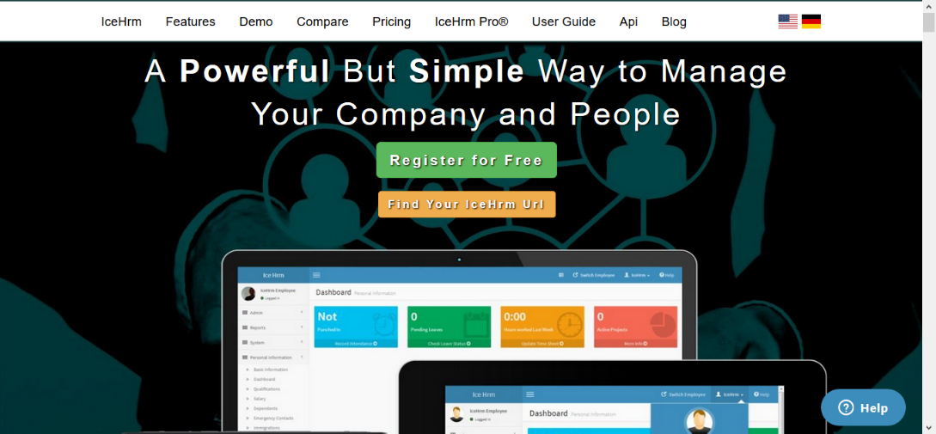

Figure 2: IceHrm Homepage

IceHrm has one of the best leave management systems among all the HRM software. Leaves module is used to define all the elements required to manage leave application process of your company, including leave periods, leave types, work week, holidays, and leave rules

**PlanMyleave**

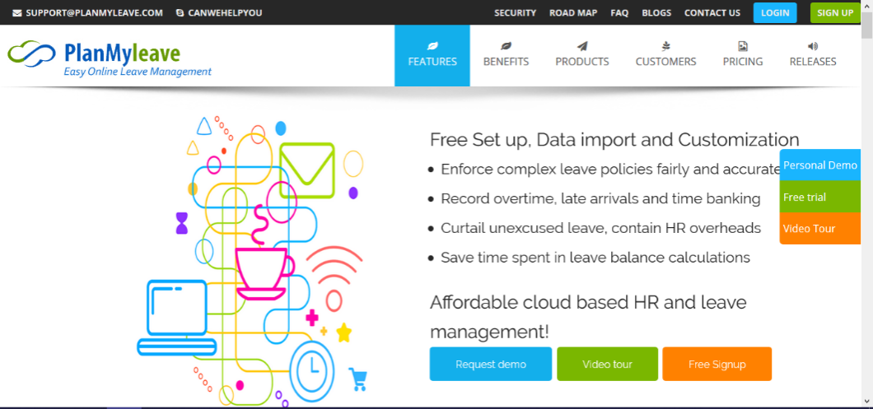

Figure 3: PlanMyLeave Homepage

PlanMyLeave is an HRIS and online leave management system designed to scale easily from small and medium businesses to large enterprises. PlanMyLeave offers the following self Service, ease of use, flexible Timings and Shifts, secure and Scalable.

**Sprout Solutions**

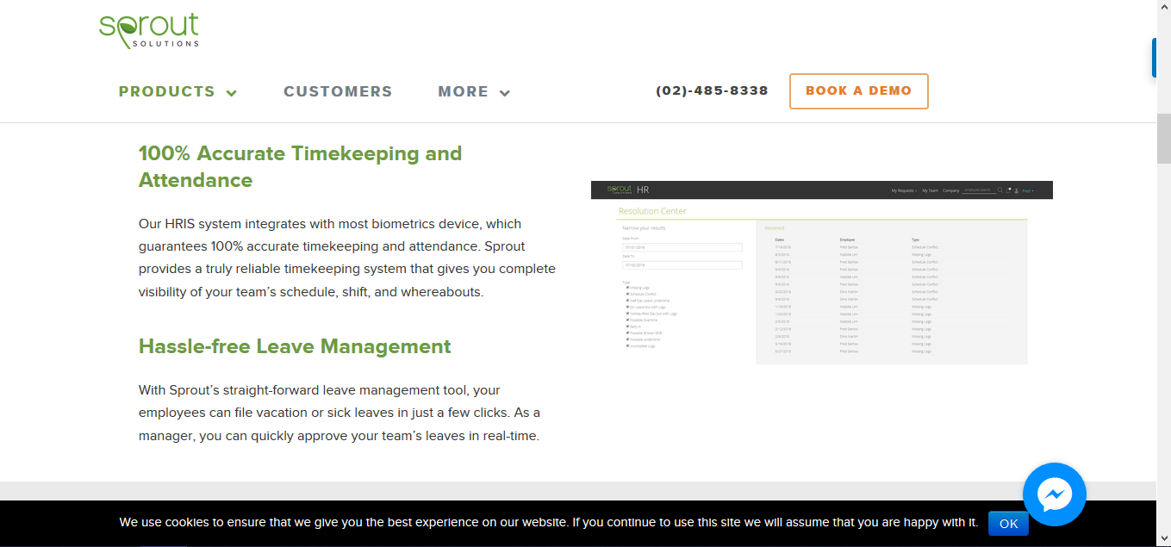

Figure 4: Sprout Solutions Homepage

Sprout Solutions automates all the administrative tasks around HR and Payroll. We take care of the dirty work so you can focus on growing your business. Filing vacation and sick leaves have never been easier! A user-friendly leave management tool that you and your employees will love.

**MyOfficeHub**

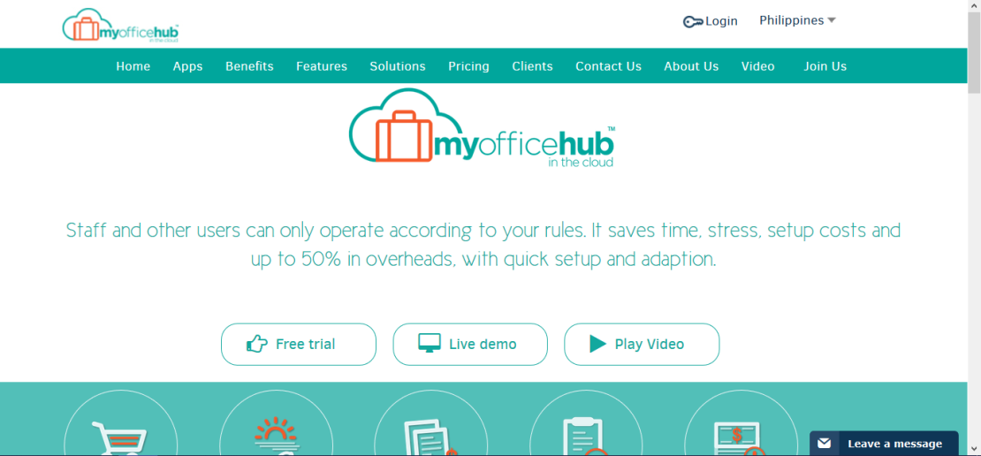

Figure 5: MyOfficeHub Homepage

Myofficehub is a professionally developed secure Hub Office platform in the cloud where the daily operational business needs of your Startup or Small or Medium business are met in one place, anytime, anywhere, on any device. Leave management system is fully integrated with our other apps.

**Zoho People**

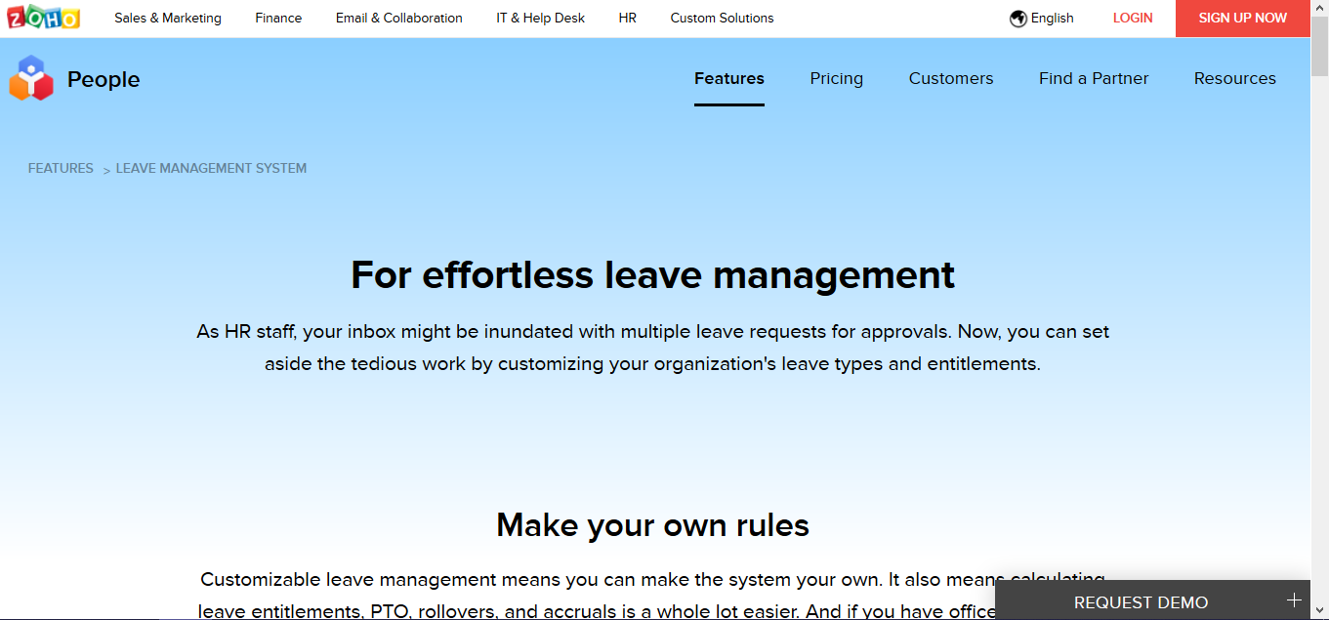

Figure 6: Zoho People Homepage

Zoho People speeds and simplifies your entire leave management process. You can record and monitor all types of leave across your organization: vacation, training, sick days. Analyze absence patterns to help maintain efficiency and reduce lost time.

### Comparative Matrix

Comparative Matrix is designed to model and evaluate the different features of the study and existing related studies and existing related system and compare and calculate the percentage according to the number of features covered among by the competitors. It evaluates certain features that are found or not by other competitors. The comparison of the related studies is itemized based on the features of the system.

Table 1

COMPARATIVE MATRIX: WEB SPECIFIC FEATURES

|  |  |  |  |  |  |  |
| --- | --- | --- | --- | --- | --- | --- |
| Features | IceHrm | PlanMy  Leave | Sprout Solutions | Myofficehub | Zoho People | Leaves  Hero |
| Automated leave management |  |  |  |  |  |  |
| Customization |  |  |  |  |  |  |
| Online leave application |  |  |  |  |  |  |
| Leave request management |  |  |  |  |  |  |
| ­Employee leaves tab lists |  |  |  |  |  |  |
| Summary of leave balances |  |  |  |  |  |  |
| Location based holidays management |  |  |  |  |  |  |
| Multi – Level Approval |  |  |  |  |  |  |
| Gender based type of leave |  |  |  |  |  |  |
| Restrictions management |  |  |  |  |  |  |
| Notification |  |  |  |  |  |  |
| Generates leave report |  |  |  |  |  |  |
| Cancellation of leave request |  |  |  |  |  |  |
| Mobile platform |  |  |  |  |  |  |
| Total (# of checks/14)*100 | 43% | 86% | 29% | 38% | 64% | 100% |

Table 2

COMPARATIVE MATRIX: MOBILE SPECIFIC FEATURES

|  |  |  |  |
| --- | --- | --- | --- |
| Features | PlanMyLeave | Zoho People | LeavesHero |
| Leave Application Management |  |  |  |
| Leave Approval |  |  |  |
| Location based holidays management |  |  |  |
| Application Notification |  |  |  |
| SMS Notification |  |  |  |
| Search colleague’s information |  |  |  |
| Customization |  |  |  |
| Cancellation of leave request |  |  |  |
| Leave request management |  |  |  |
| Summary of leave balances |  |  |  |
| Restrictions management |  |  |  |
| Total = (No. of checks/11)*100 | 36% | 27% | 90% |

The tables above show an integrated comparative matrix result for the four (5) related studies consist of IceHrm, PlanMyLeave, Sprout Solutions, MyOfficeHub, and Zoho People. In the conclusion that LeavesHero has features that are distinct or unique, compared to its competitors and offers both The Web and Mobile real-time synchronization.

# 

# CHAPTER III

# RESEARCH METHODOLOGY

## Software Engineering Methodology

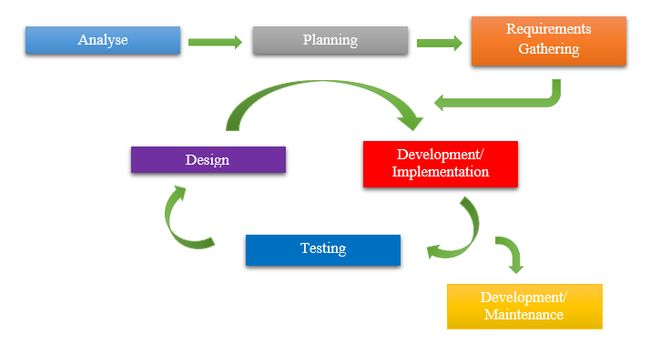

Deployment   
Maintenance

Figure 6: Software Engineering Methodology

Agile software development describes an approach to [software development](https://en.wikipedia.org/wiki/Software_development) under which requirements and solutions evolve through the collaborative effort of self-organizing [cross-functional teams](https://en.wikipedia.org/wiki/Cross-functional_team) and their [customer(s)](https://en.wikipedia.org/wiki/Customer)/[end users(s)](https://en.wikipedia.org/wiki/End_user). It advocates adaptive planning, evolutionary development, early delivery, and continuous improvement, and it encourages rapid and flexible response to change. The term agile was popularized, in this context, by the Manifesto for Agile Software Development. The values and principles espoused in this manifesto were derived from and underpin a broad range of [software development frameworks](https://en.wikipedia.org/wiki/Software_development_process), including [Scrum](https://en.wikipedia.org/wiki/Scrum_(software_development)) and [Kanban](https://en.wikipedia.org/wiki/Kanban_(development)). Some empirical studies of agile software development found no scientific evidence that adopting practices or values associated with agile software development affects the agility of software professionals, teams or organizations.

## Planning/Conception-Initiation Phase

### Business Model Canvas

Business Model Canvas is a strategic management and lean startup template for developing new or documenting existing business models. It is a visual chart with elements describing a firm or product’s value proposition, infrastructure, customers, and finances.

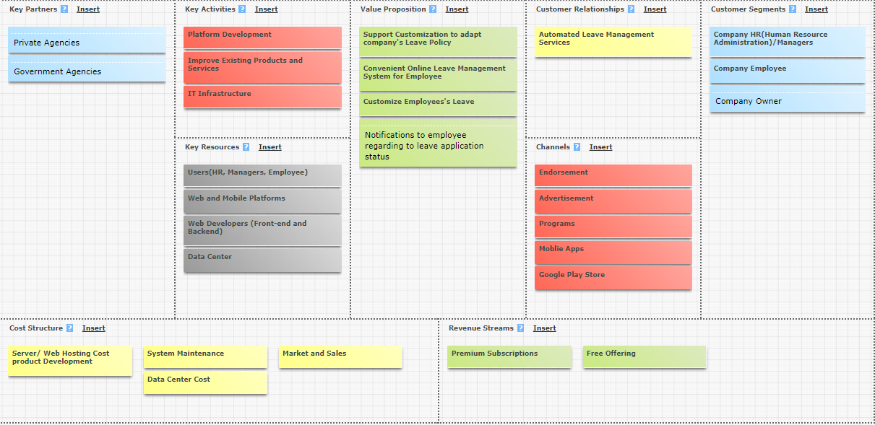

Figure 7: Business Model Canvas

Figure 7 shows the strategic management for the business operation of the capstone project which described its value proposition, infrastructure, customers, and finances.Customer relationship is an approach to manage a company's interaction with current and potential customers. It uses data analysis about customers' history with a company to improve business relationships with customers, specifically focusing on customer retention and ultimately driving sales growth.The Revenue Stream is the building block presenting the cash a company generates from each Customer Segment. Most businesses need at least one great revenue stream to earn money.

### 

### Program Workflow

Program workflow is an illustration of application which automates, to at least some degree, a process or processes. The processes are usually business-related but can be any process that requires a series of steps to be automated via software.

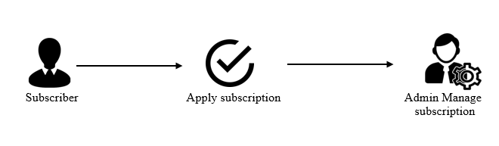

Figure 8: Program Workflow –Super Admin

Each company can apply subscription, then it will be managed by the super admins.

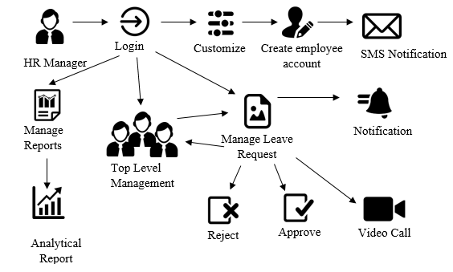

Figure 9: Web/ Mobile Program Workflow – HR Manager/ Company Owner /Approver (Admins)

On this figure, after the company owner watches and observes our system, he/she can apply subscription. And after that, the HR Manager or the company owner can manage the system contents, which include customization to adapts the company’s HR policies and also the HR manager is the one who will delete, update, and create the employees account after that the HR will send the account details through SMS to their respective employees, manage reports which include the analytical report, manage to leave request which includes leave approval, rejection and sent it to another approver/s or to the top management. When the employee applied for a leave the HR manager or the approver/s will notify the same thing when the HR manager approves or reject the request the employee will also receive notification.

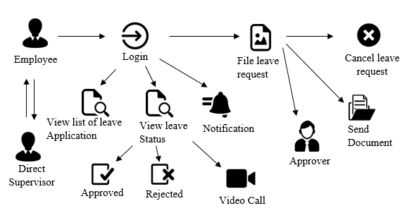

Figure 10:Web / Mobile Program Workflow – Employee (User)

On this figure, after the HR manager customizing the application to adopt the company’s HR policies. Employee can file leave request to the HR, s/he can cancel the request and can also attach supporting documents like medical certificate etc. and send to the leave approvers, the employee can communicate to his/her direct supervisor, employee will receive a notification if the HR manager approve or reject the leave request, and the employee can also view list of leave application, and leave taken like leave types and number of days.

### Validation Board

Validation Board is a tool that is used by the proponents to evaluate if the proposed system problem does exist in the real world. The validation evaluates if there is a potential market for the system in the society.

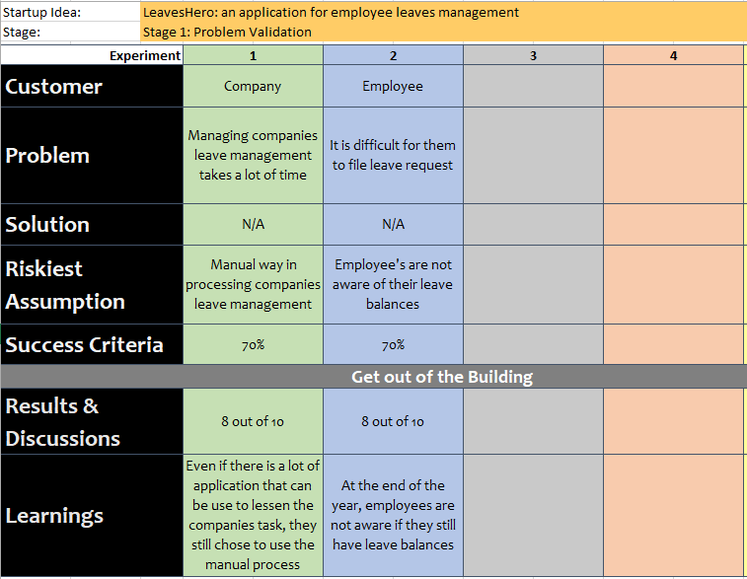

Figure 11: LeavesHero –Stage 1 Validation Board

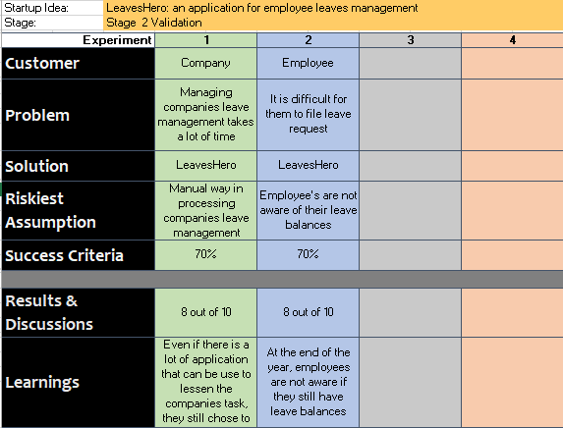

Figure 12: Stage 2 Validation Board

The figure shows the problems and results based on an interview by researchers and it will determine if the proposed study is viable. Solution to each problem is included.

### Gantt Chart

A Gantt chart is a type of bar chart that illustrates a project schedule.

Table 3

GANTT CHART

|  |  |  |  |  |  |  |  |  |  |  |  |  |  |  |  |
| --- | --- | --- | --- | --- | --- | --- | --- | --- | --- | --- | --- | --- | --- | --- | --- |
| Task ID | Task Name | Task Lead | Duration | July 2018 | August 2018 | | | | September 2018 | | | | October 2018 | | |
| 4 w | 1w | 2w | 3w | 4w | 1w | 2w | 3w | 4w | 1w | 2w | 3w |
| 1 | Title hearing | Team | 1 Day |  |  |  |  |  |  |  |  |  |  |  |  |
| 2 | Meeting with the adviser | Team | 1 Day |  |  |  |  |  |  |  |  |  |  |  |  |
| 3 | Introduction | Hipster  Hustler | 3 Days |  |  |  |  |  |  |  |  |  |  |  |  |
| 4 | Rationale of the Study | Hipster | 3 Days |  |  |  |  |  |  |  |  |  |  |  |  |
| 5 | Objectives of the Study | Team | 6 Days |  |  |  |  |  |  |  |  |  |  |  |  |
| 6 | Scope and Limitations | Team | 6 Days |  |  |  |  |  |  |  |  |  |  |  |  |
| 7 | Significance of the Study | Hacker | 1 Day |  |  |  |  |  |  |  |  |  |  |  |  |
| 8 | Flow of the Study | Hustler | 1 Day |  |  |  |  |  |  |  |  |  |  |  |  |
| 9 | Definition of Terms | Hacker | 1 Day |  |  |  |  |  |  |  |  |  |  |  |  |
| 10 | Related Literature | Hipster | 6 Days |  |  |  |  |  |  |  |  |  |  |  |  |
| 11 | Related Studies | Hacker  Hustler | 5 Days |  |  |  |  |  |  |  |  |  |  |  |  |
| 12 | Comparative Matrix | Team | 2 Days |  |  |  |  |  |  |  |  |  |  |  |  |
| 13 | Software Methodology | Hacker | 2 Days |  |  |  |  |  |  |  |  |  |  |  |  |
| 14 | Business Model Canvas | Team | 1 Day |  |  |  |  |  |  |  |  |  |  |  |  |
| 15 | Program Workflow | Hipster | 2 Weeks |  |  |  |  |  |  |  |  |  |  |  |  |
| 16 | Validation Board | Team | 4 Weeks |  |  |  |  |  |  |  |  |  |  |  |  |
| 17 | Gantt Chart | Hipster | 1 Day |  |  |  |  |  |  |  |  |  |  |  |  |
| 18 | Functional Decomposition Diagram | Team | 8 Weeks |  |  |  |  |  |  |  |  |  |  |  |  |
| 19 | Use Case Diagram | Team | 8 Weeks |  |  |  |  |  |  |  |  |  |  |  |  |
| 20 | Storyboard | Hipster | 3 Weeks |  |  |  |  |  |  |  |  |  |  |  |  |
| 21 | Entity Relationship Diagram | Team | 4 Weeks |  |  |  |  |  |  |  |  |  |  |  |  |
| 22 | Network Design | Hacker | 2 Days |  |  |  |  |  |  |  |  |  |  |  |  |
| 23 | Network Topology | Hacker | 2 Days |  |  |  |  |  |  |  |  |  |  |  |  |
| 24 | Technology Stack Diagram | Hacker | 2 Days |  |  |  |  |  |  |  |  |  |  |  |  |
| 25 | Software Specification | Team | 2 Days |  |  |  |  |  |  |  |  |  |  |  |  |
| 26 | Hardware Specification | Team | 2 Days |  |  |  |  |  |  |  |  |  |  |  |  |
| 27 | Program Specification | Team | 2 Days |  |  |  |  |  |  |  |  |  |  |  |  |
| 28 | List of modules | Team | 4 Weeks |  |  |  |  |  |  |  |  |  |  |  |  |

### Functional Decomposition Diagram

A functional decomposition diagram shows a high-level function, process, organization, data subject area, or another type of object broken down into lower level, more detailed components.

Figure 13: Functional Decomposition Diagram - Web

The Functional Decomposition Diagram for Web Platform has three main management, these are the Registration that is breakdown into User Account, Customization, and Holidays. In the web, the transaction is breakdown into Subscription, Payment, Leave Application, and Leave Approval. LeavesHero’s admin receives leave request from the user which is the employees, and get notified for an upcoming holiday. Users receive yearly throwbacks about their past leave application, get updates about their leave request status and upcoming holidays. Lastly, LeavesHero generates monthly and annual analytical report, advance leave report, consecutive leave report, leave balances of the employees which can also be seen by the employee, and history of all events in the system.

Figure 14: Functional Decomposition Diagram - Mobile

The Functional Decomposition Diagram for Mobile Platform has three main management, these are the Registration that is breakdown into User Account, Customization, and Holidays. In the mobile, the transaction is breakdown into Leave Application and Leave Approval. LeavesHero’s admin receives leave request from the user which is the employees, and get notified for an upcoming holiday. Users receive yearly throwbacks about their past leave application, get updates about their leave request status and upcoming holidays. Lastly, LeavesHero generates monthly and annual analytical report, advance leave report, consecutive leave report, leave balances of the employees which can also be seen by the employee, and history of all events in the system.

## Analysis-Design Phase

### Use Case Diagram

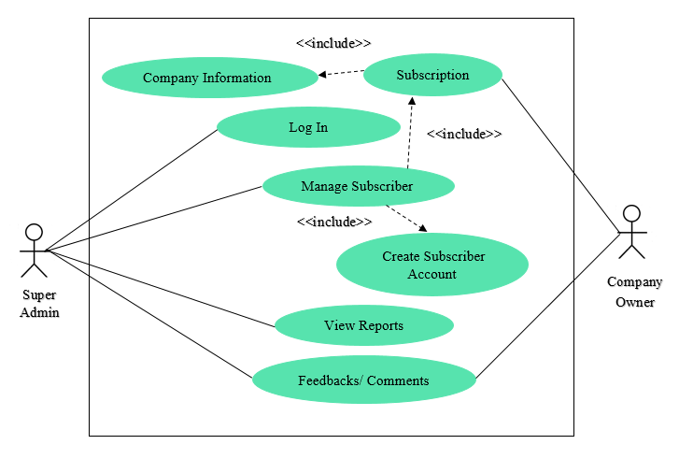A use case diagram at its simplest is a representation of a user's interaction with the system that shows the relationship between the user and the different use cases in which the user is involved.

Figure 15: Use Case Diagram – Super Admin and Company Owner

Figure 17 shows the use case diagram which is the interaction between the company and the admin within the application. The company and the admin interaction shows the complete activities that they can do within the system.

**­­­**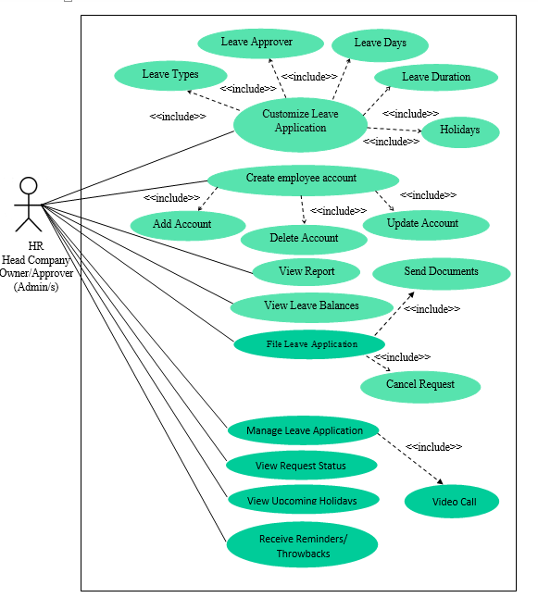

Figure 16: Use Case Diagram - HR, Company Owner, and Approver (Admin)

Figure 18 shows the use case diagram of the HR Head, Company Owner, Approver and employee within the application. It also shows the complete activities that they can do within the system. In addition, they are both users of the system at the same.

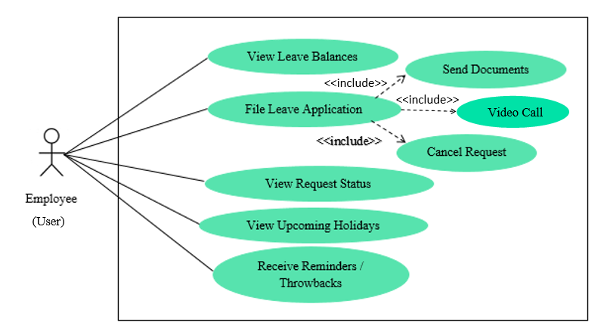

Figure 17: Use Case Diagram – Employee (User)

Figure 19 shows the employees’ activity within the system. The employee can view their remaining leave balances, file leave application and attached supporting document, view request status, view upcoming holidays, and get reminders or throwbacks from the past leave they take.

### Storyboard

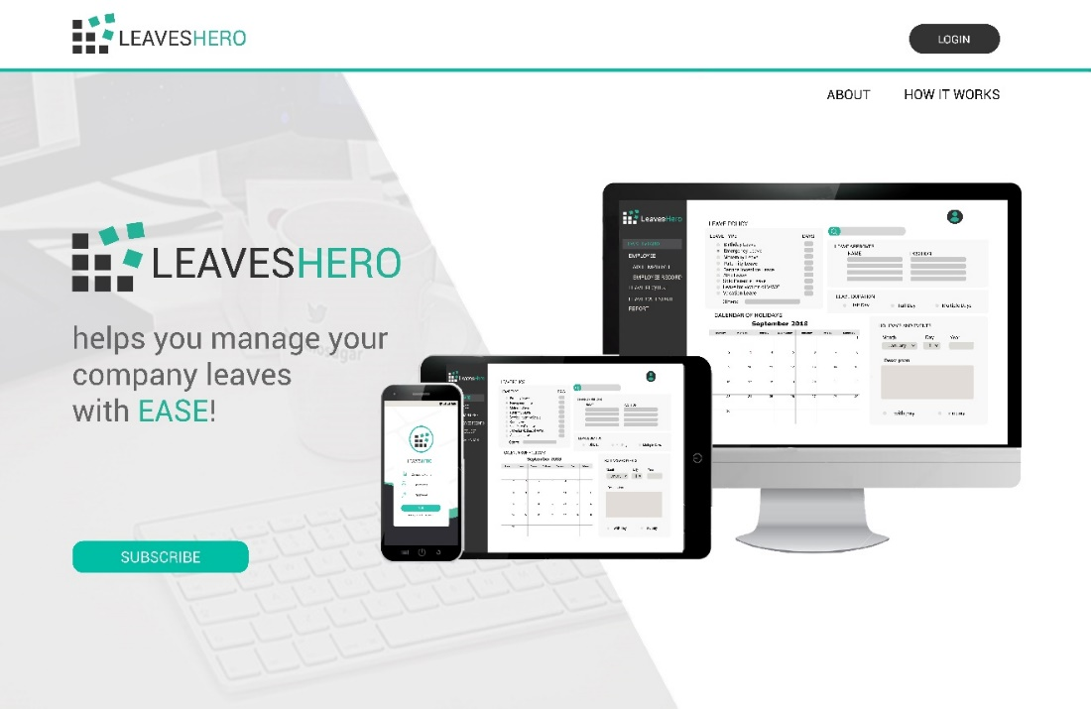

Figure 18: LeavesHero –Homepage

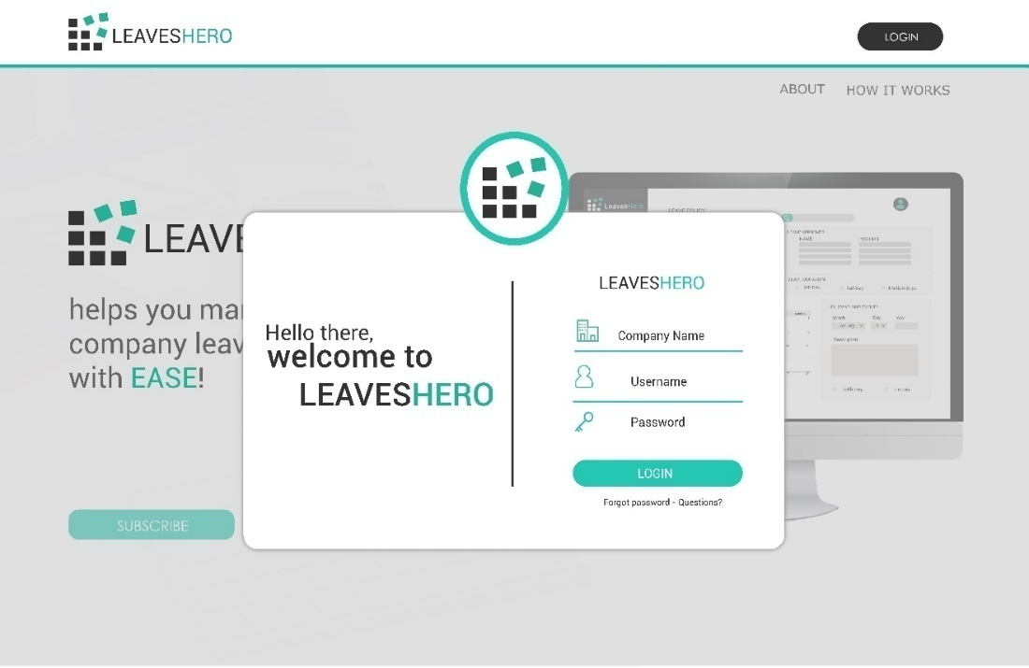

Figure 19: LeavesHero - Web Log In

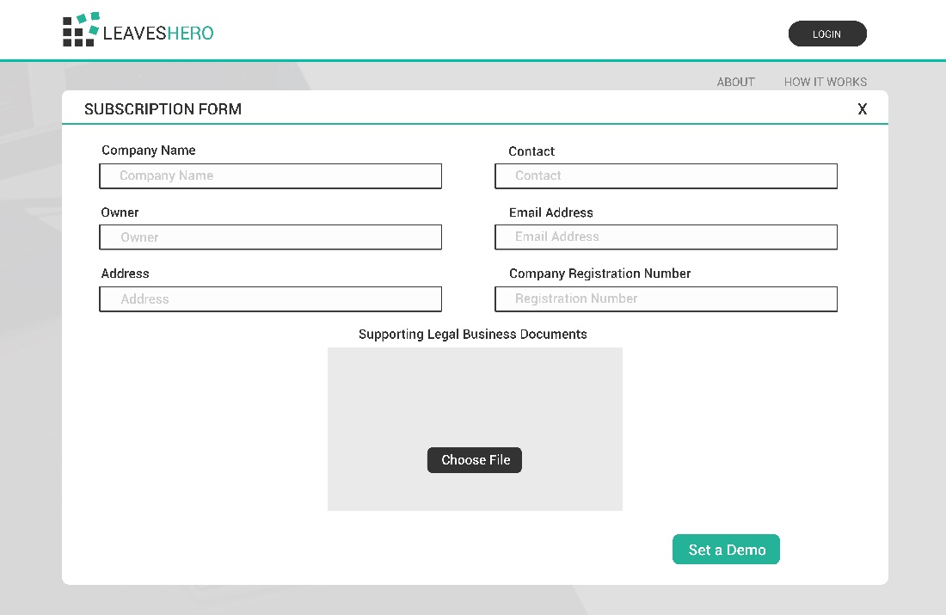

Figure 20: LeavesHero - Subscription Form

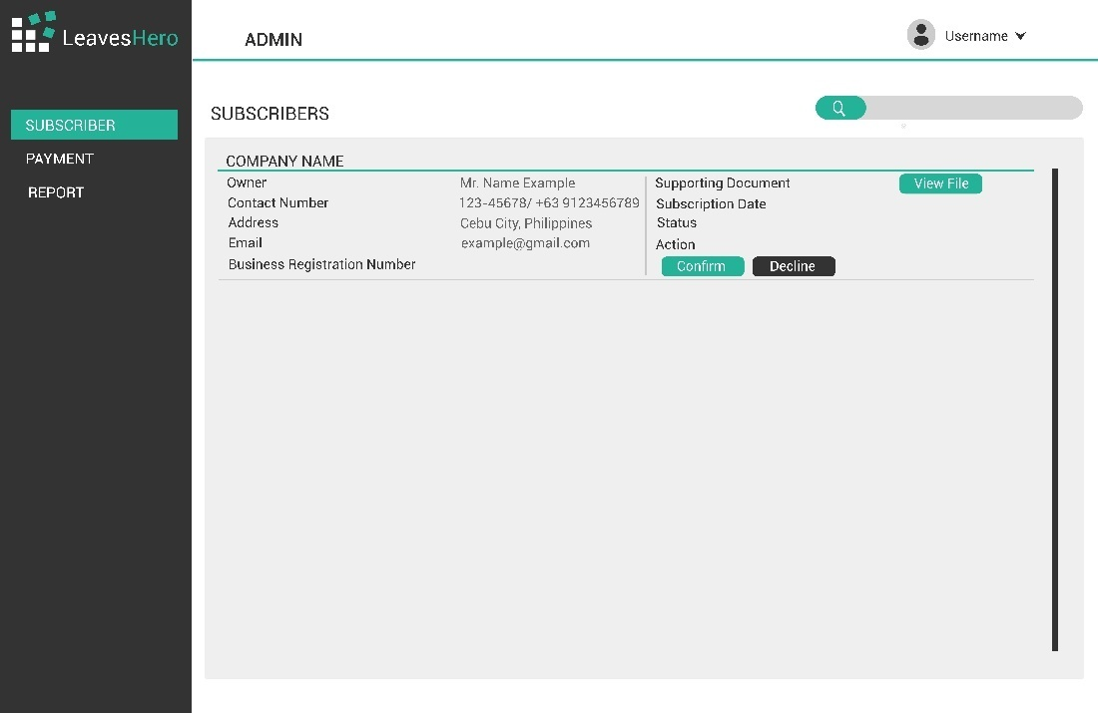

Figure 21: LeavesHero – Subscribers Table

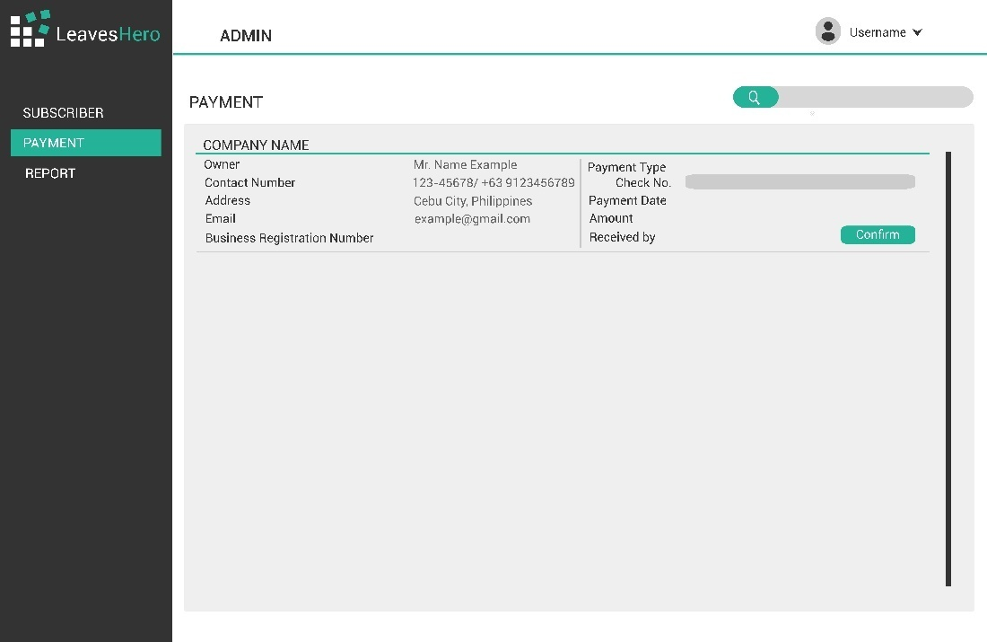

Figure 22: LeavesHero - Payment Record (Super Admin)

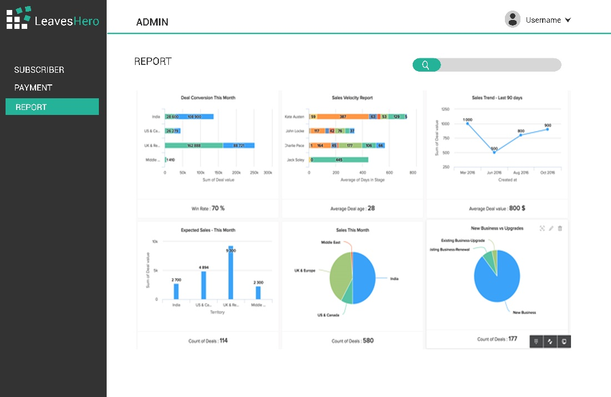

Figure 23: LeavesHero - Report Page (Super Admin)

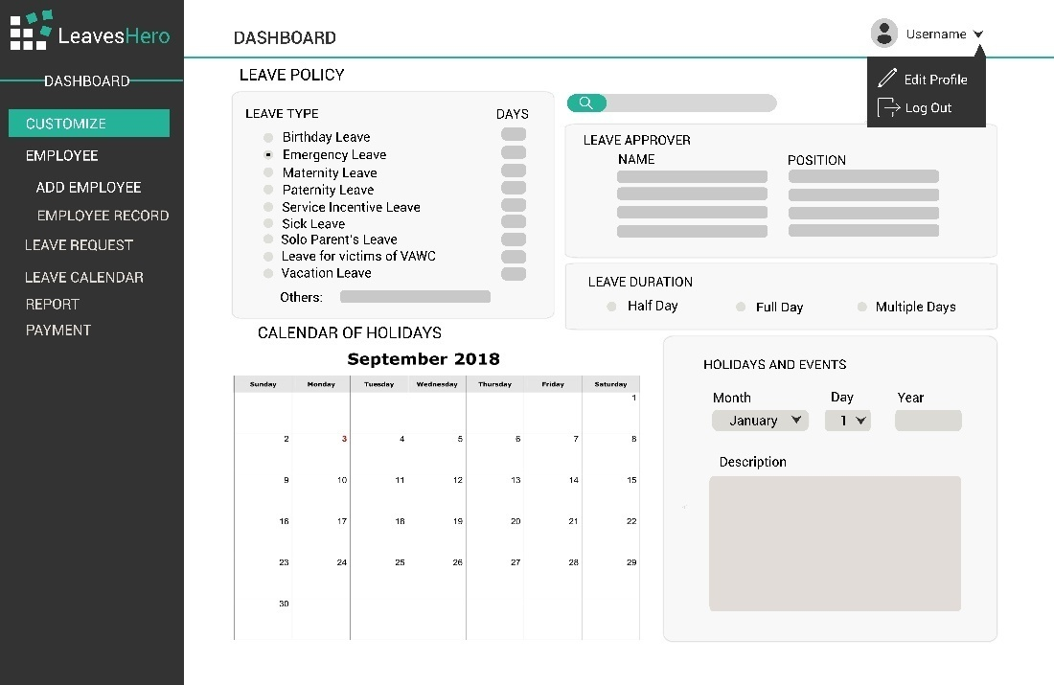

Figure 24: LeavesHero - Customization Page (Admin)

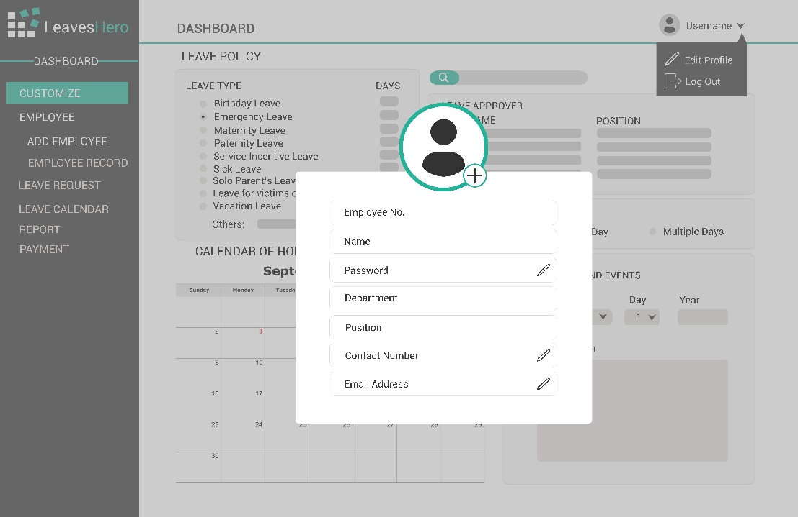

Figure 25: LeavesHero - Edit Profile Form (Admin)

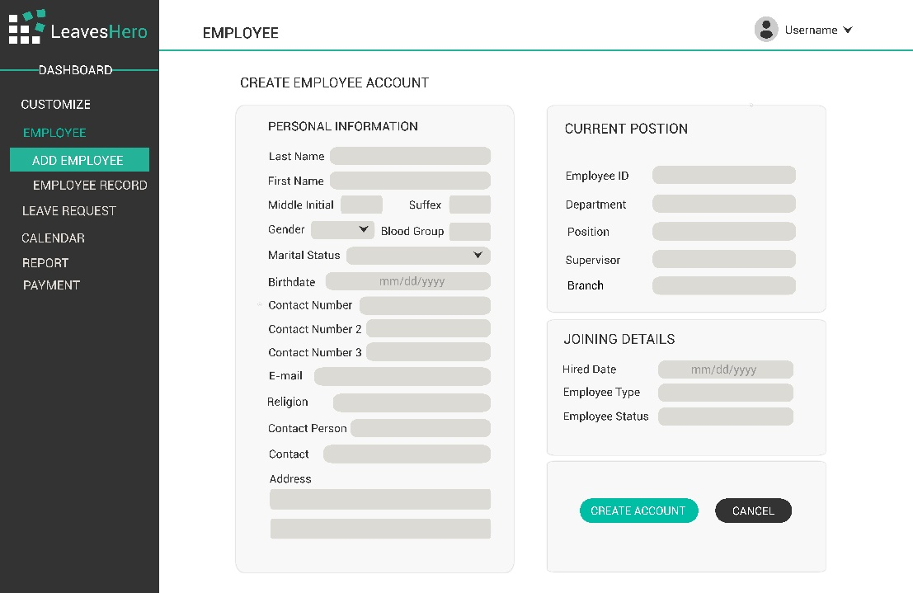

Figure 26: LeavesHero - Add Employee Page (Admin)

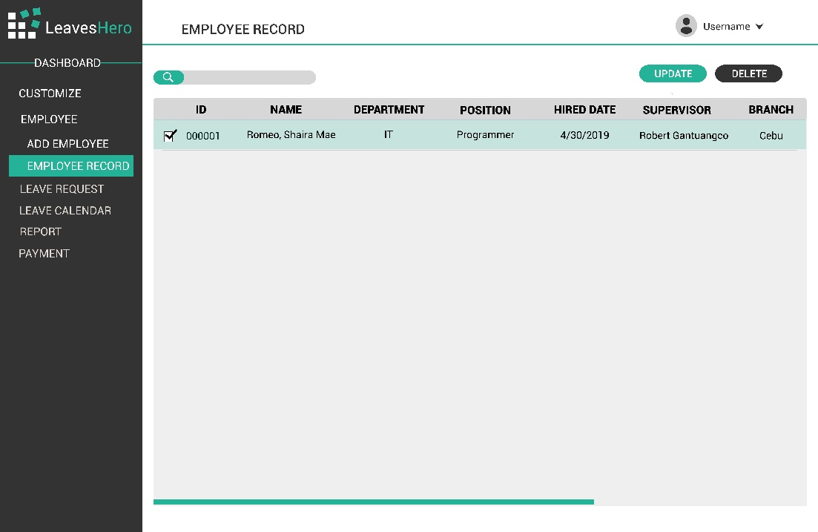

Figure 27: LeavesHero - Employee Record Page (Admin)

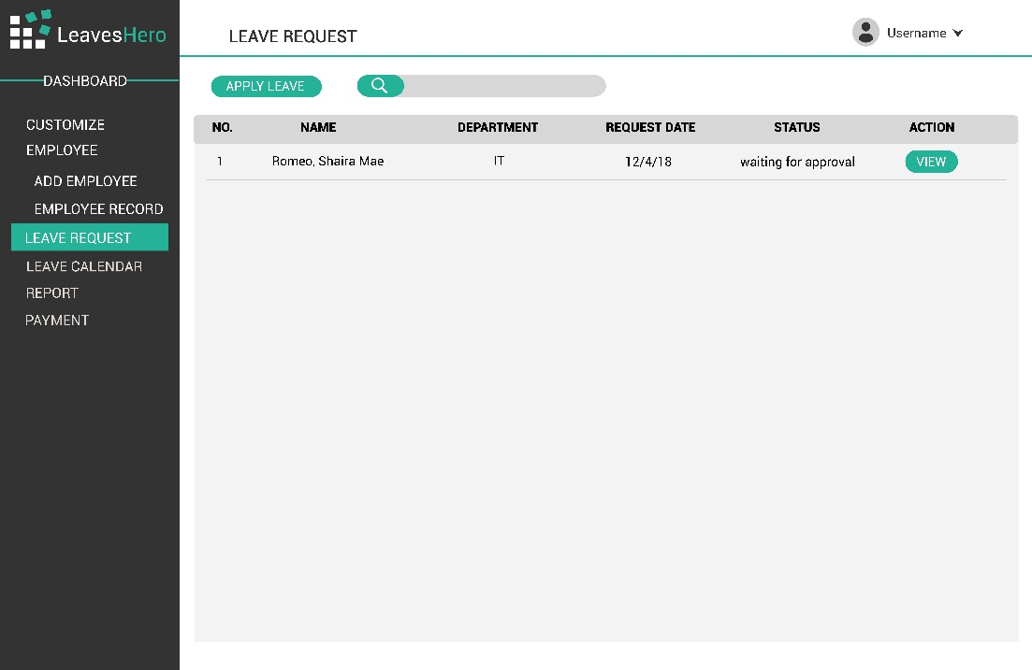

Figure 28: LeavesHero - Leave Request Table (Admin)

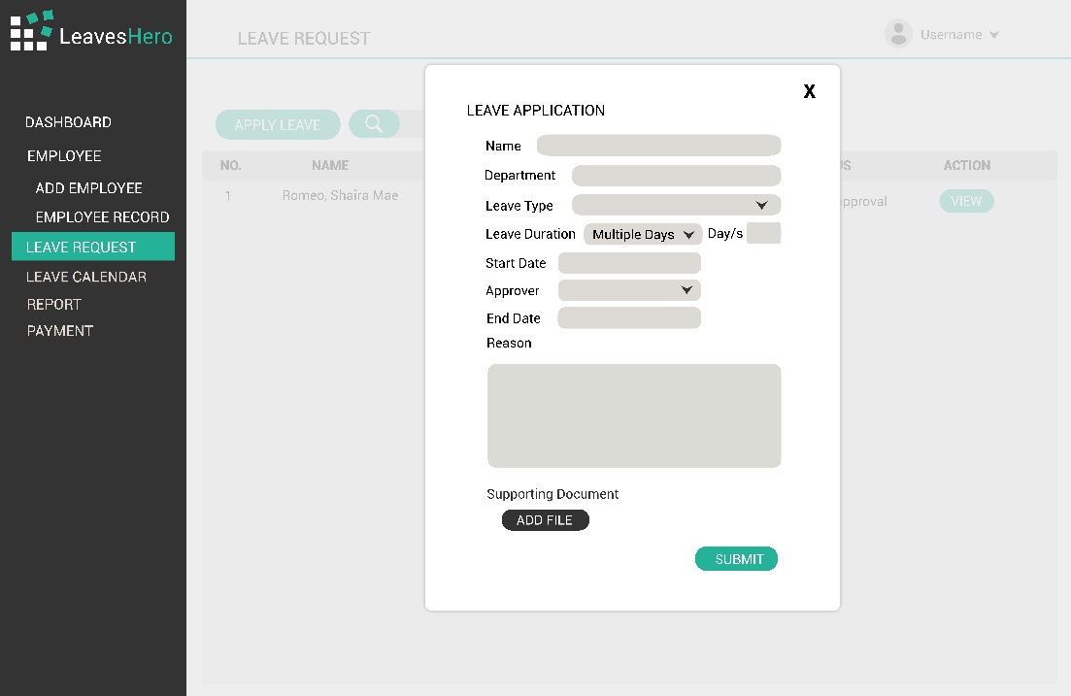

Figure 29: LeavesHero - Leave Application Form (Admin)

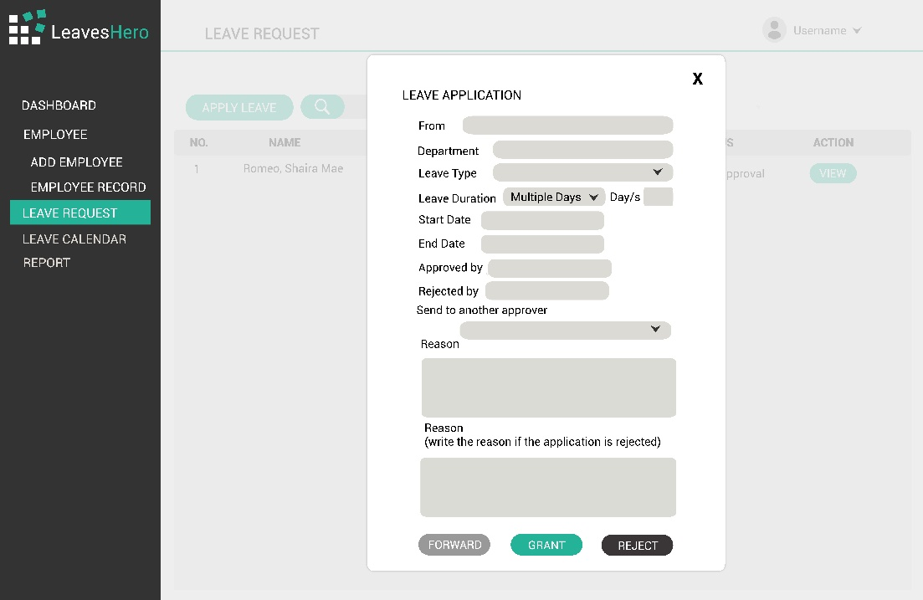

Figure 30: LeavesHero - Leave Request Form (Admin)

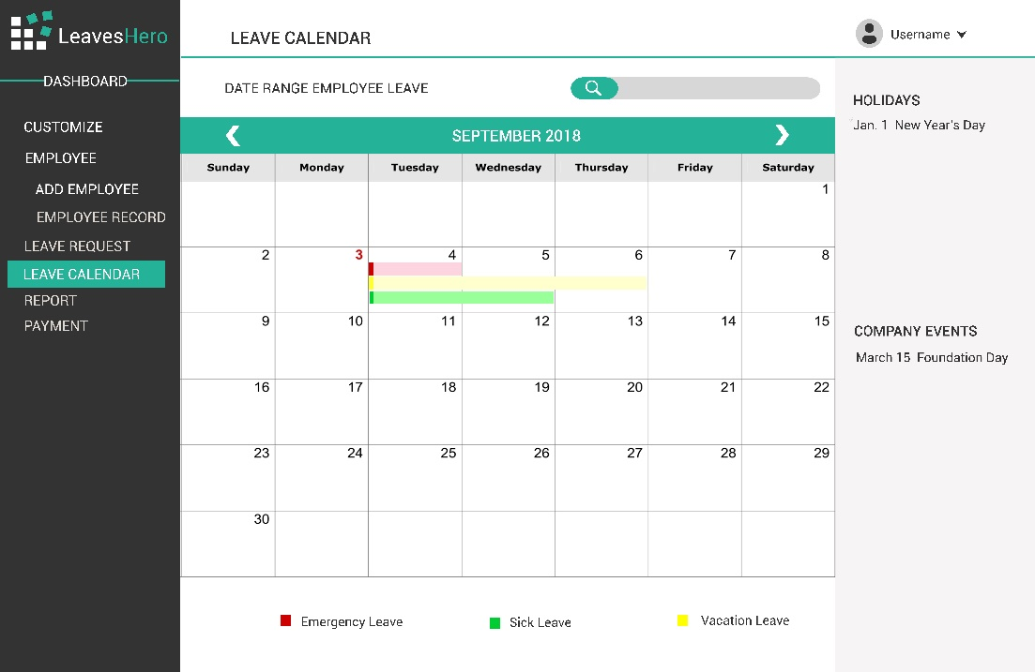

Figure 31: LeavesHero - Calendar Page (Admin)

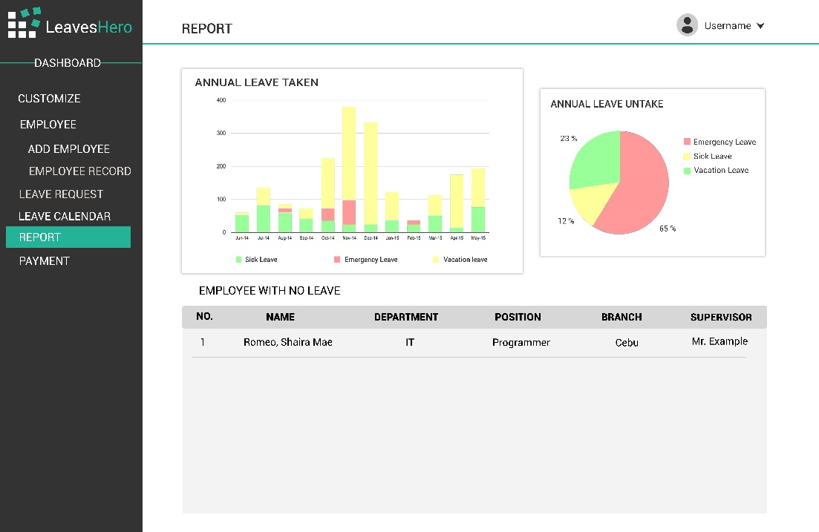

Figure 32: LeavesHero - Report Page (Admin)

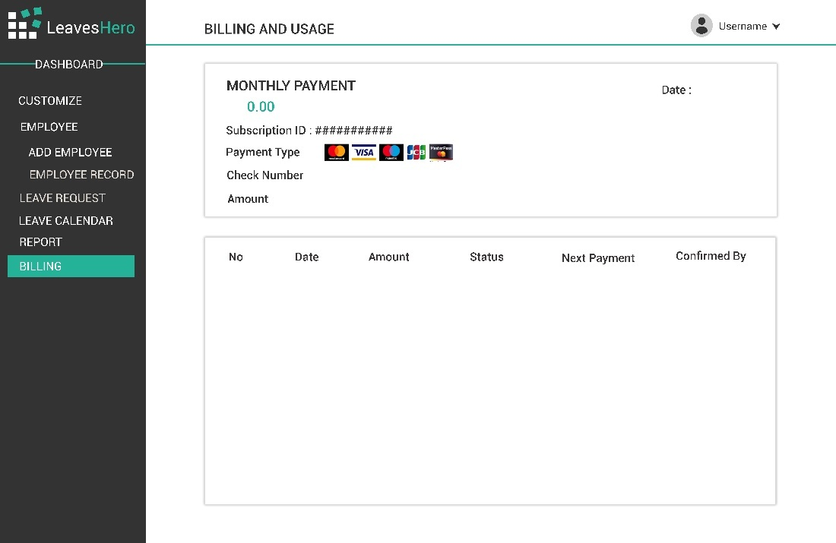

Figure 33: LeavesHero - Billing Page (Admin)

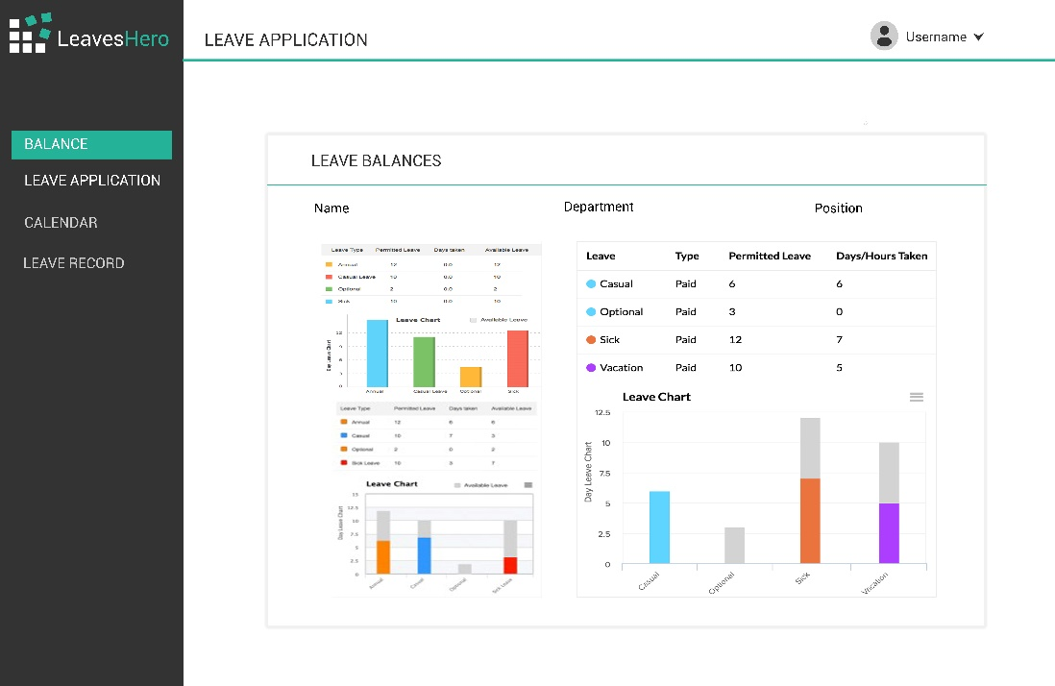

Figure 34: LeavesHero - Leave Balances Page (User)

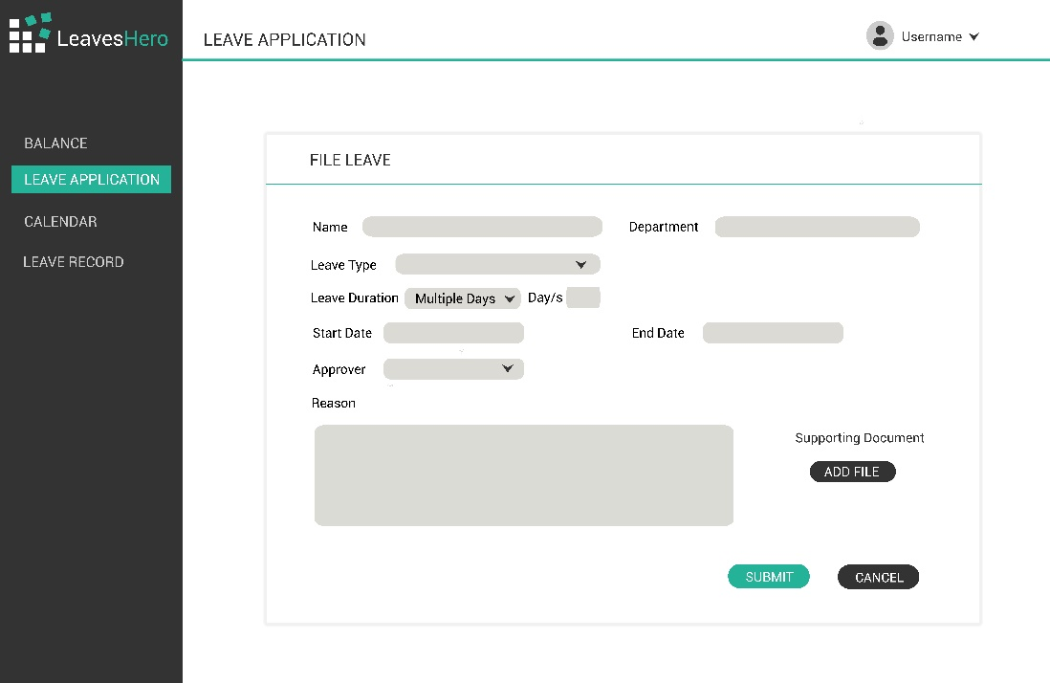

Figure 35: LeavesHero - Employee’s Leave application Form (User)

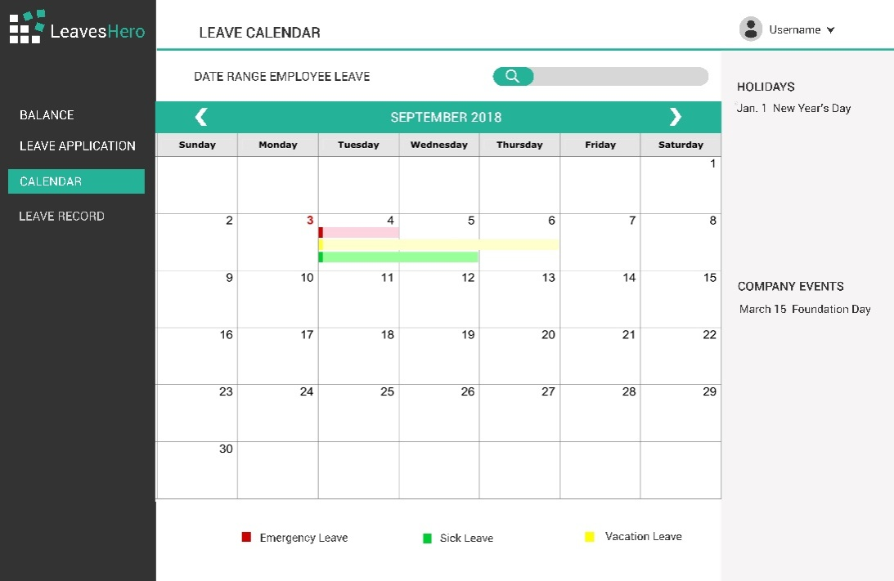

Figure 36: LeavesHero - Employee's Calendar (User)

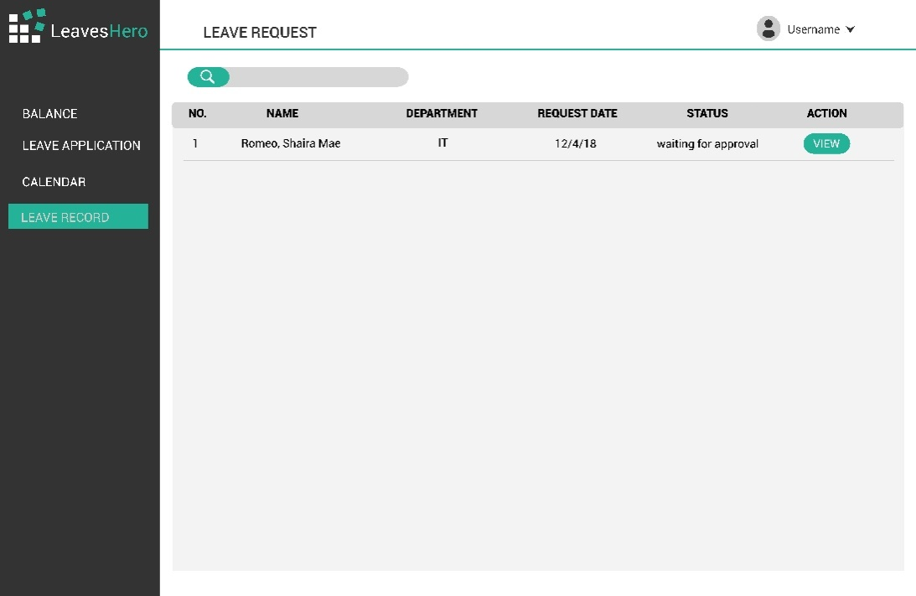

Figure 37: LeavesHero - Employees' Leave Record Page (User)

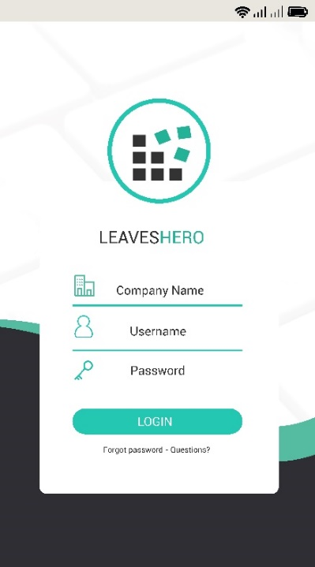

Figure 38: LeavesHero - Mobile Log In Form

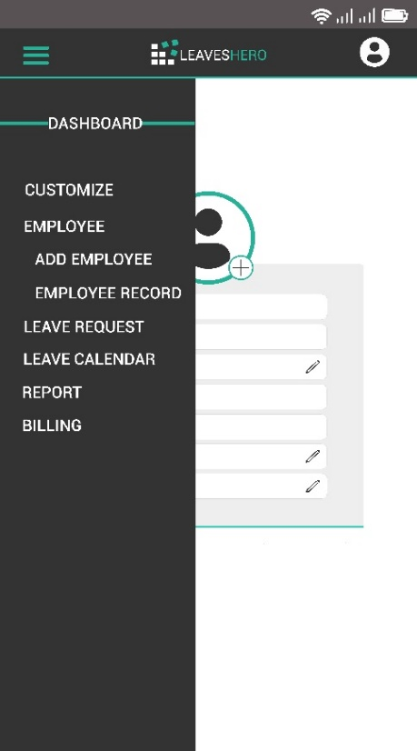

Figure 39: LeavesHero - Mobile Menu (Admin)

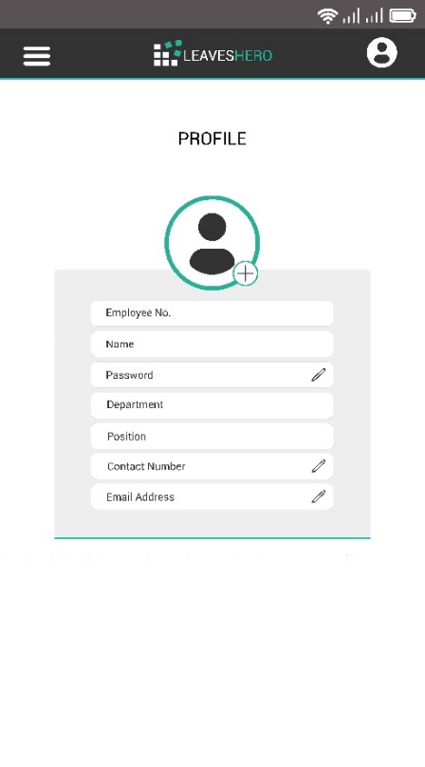

Figure 40: LeavesHero - Mobile Profile (Admin)

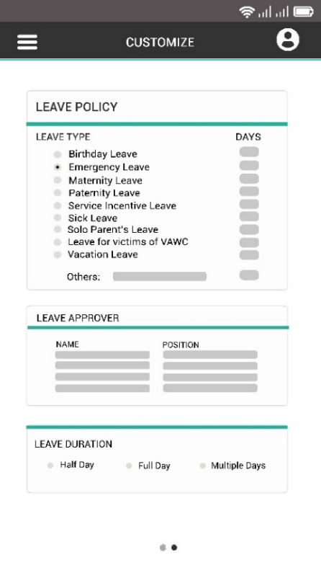

Figure 41: LeavesHero - Mobile Customization Page (Admin)

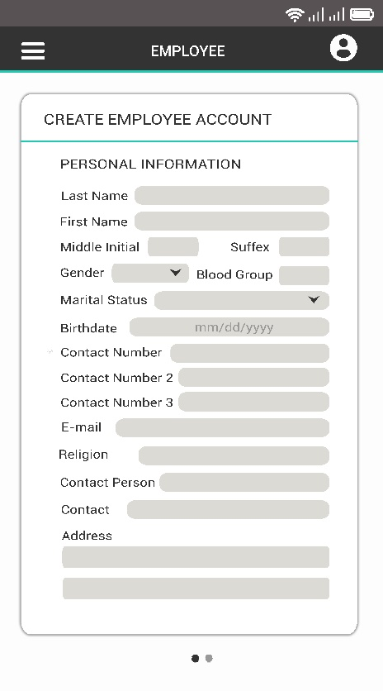

Figure 42: LeavesHero - Mobile Employee Registration (Admin)

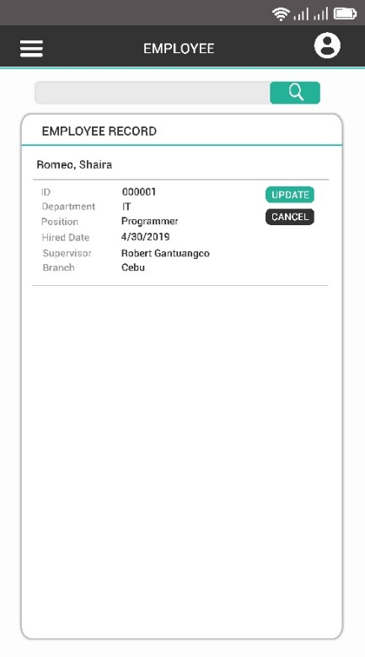

Figure 43: LeavesHero - Mobile Employee Table (Admin)

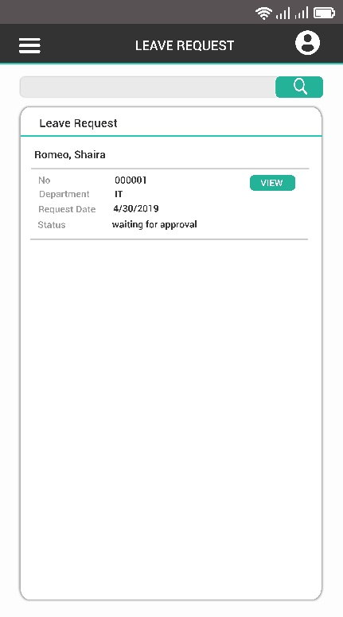

Figure 44: LeavesHero - Mobile Leave Request Table (Admin)

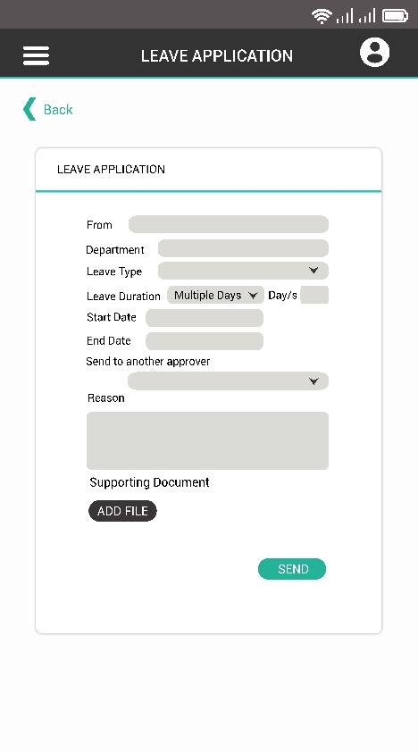

Figure 45: LeavesHero - Mobile Leave Application Form

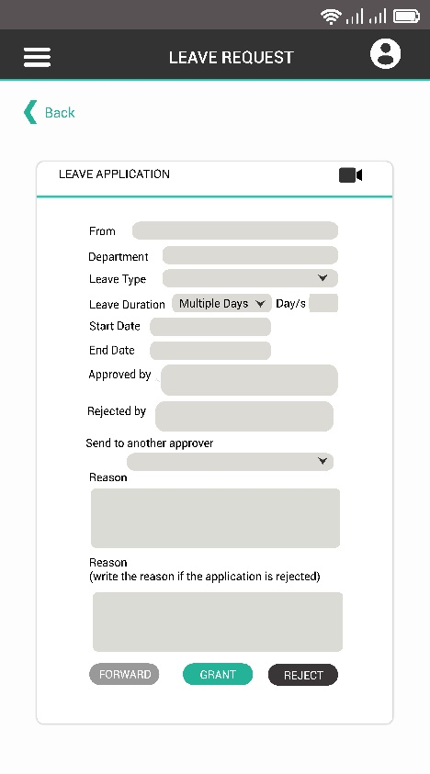

Figure 46: LeavesHero - Mobile Leave Request Approval (Admin)

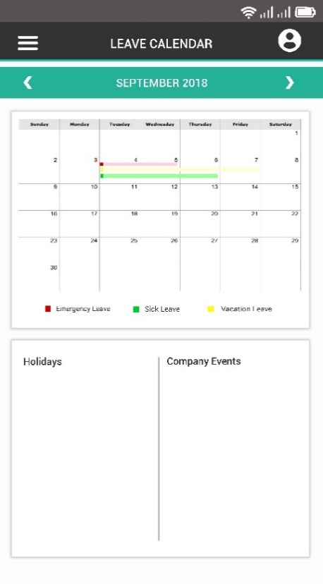

Figure 47: LeavesHero - Mobile Calendar

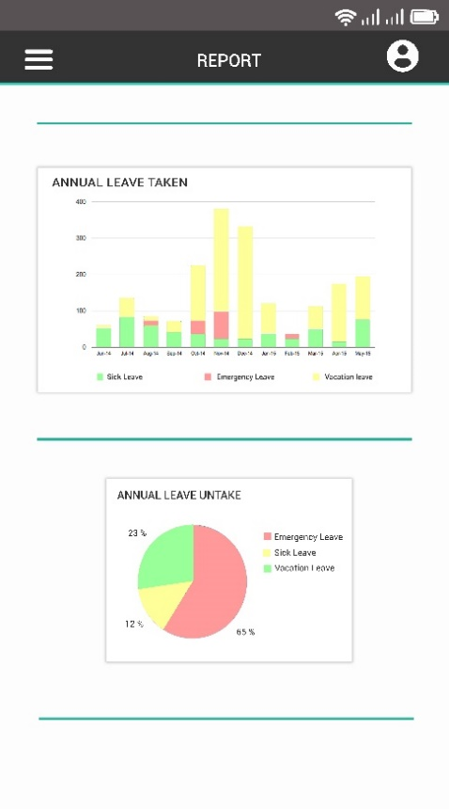

Figure 48: LeavesHero - Mobile Report (Admin)

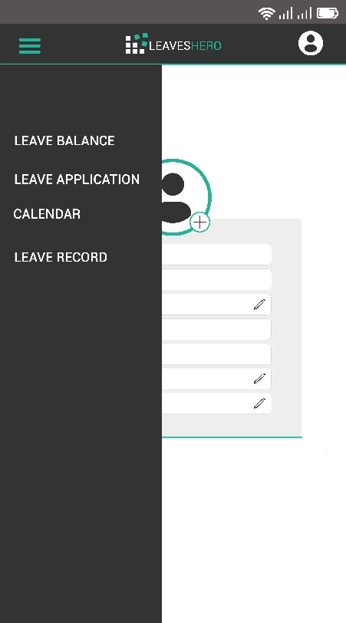

Figure 49: LeavesHero - Employee Menu

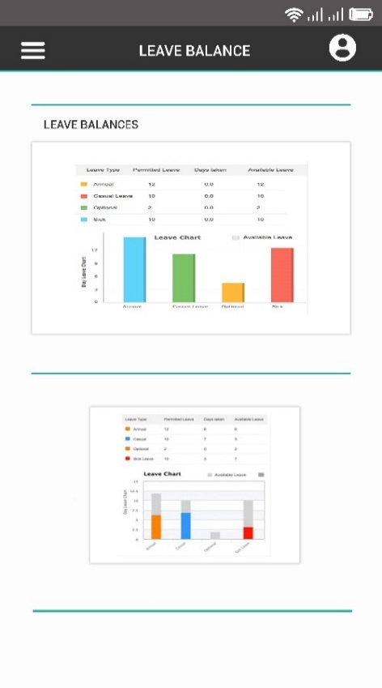

Figure 50: LeavesHero - Leave Balances Page

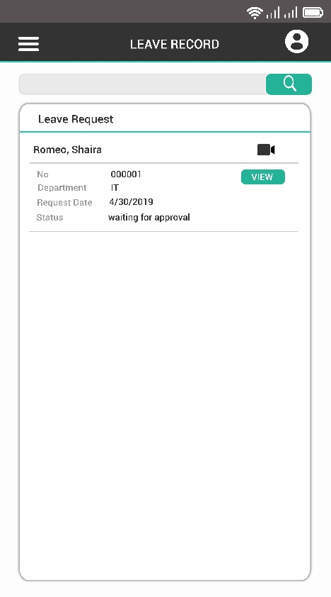

Figure 51: LeavesHero - Employees' Leave Record

### Database Design

Database design is the process of producing a detailed data model of a database. This data model contains all the needed logical and physical design choices and physical storage parameters needed to generate a design in a data definition language, which can then be used to create a database. A fully attributed data model contains detailed attributes for each entity.

#### 

#### **Entity-Relationship Diagram**

An entity-relationship diagram (ERD) is a data modeling technique that graphically illustrates an information system’s entities and the relationships between those entities. An ERD is a conceptual and representational model of data used to represent the entity framework infrastructure.

Figure 52: Entity- Relationship Diagram

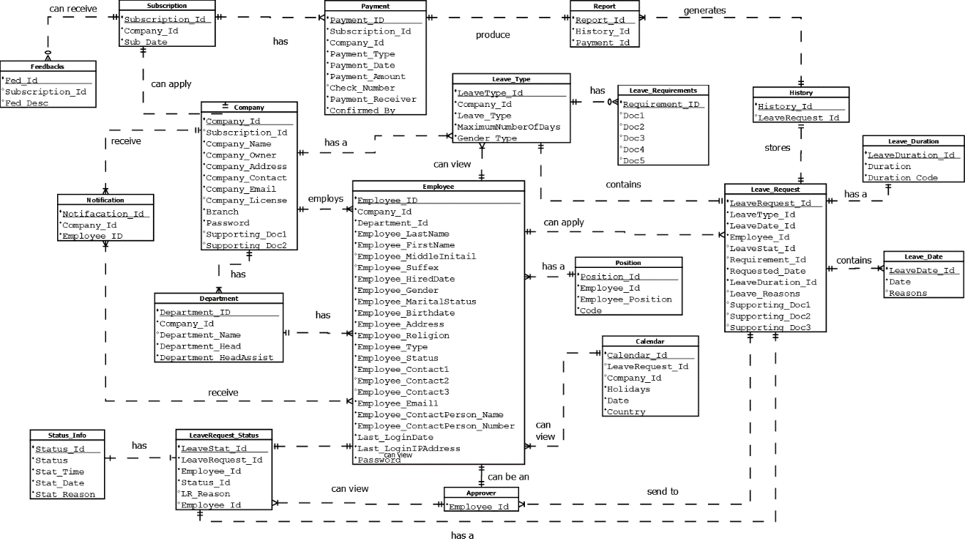

#### **Data Dictionary**

Data Dictionary is a set of information describing the contents, format, and structure of a database and the relationship between its elements, used to control access to and manipulation of the database.

Table 4

SUBSCRIPTION

|  |  |  |  |  |
| --- | --- | --- | --- | --- |
| Field Name | Description | Data Type | Length | Null Characteristics |
| Subscription_Id | Primary Key | INT |  | NO |
| Sub_Date | Date Created | DATE |  | NO |
| Company_Id | Foreign Key | INT |  | NO |
| Subscription_Type | Subscription Type | Varchar |  | NO |

Table 5

FEEDBACK

|  |  |  |  |  |
| --- | --- | --- | --- | --- |
| Field Name | Description | Data Type | Length | Null Characteristics |
| Fed_Id | Primary Key | INT |  | NO |
| Subscription_Id | Foreign Key | DATE |  | NO |
| Fed_Desc | Feedback Description | VARCHAR | 25 | NO |

Table 6  
COMPANY

|  |  |  |  |  |
| --- | --- | --- | --- | --- |
| Field Name | Description | Data Type | Length | Null Characteristics |
| Company_Id | Primary Key | INT |  | NO |
| Subscription_Id | Foreign Key | INT |  |  |
| Company_Name | Company’s Name | VARCHAR | 45 | NO |
| Company_Owner | Company‘s Owner | VARCHAR | 45 | NO |
| Company_Address | Company’s Address | VARCHAR | 45 | NO |
| Company_Contact | Company’s Contact | VARCHAR | 15 | NO |
| Company_Email | Company’s Email Address | VARCHAR | 45 | NO |
| Company_License | Company’s License | VARCHAR | 45 | NO |
| Branch | Company’s Branch | VARCHAR | 45 | NO |
| Password | Company’s Password | VARCHAR | 45 | NO |
| Supporting_Doc1 | First Supporting Document from the Company | VARCHAR | 45 | NO |
| Supporting_Doc2 | Second Supporting Document from the Company | VARCHAR | 45 | NO |
| Supporting_Doc3 | Third Supporting Document from the Company | VARCHAR | 45 | NO |

Table 7

DEPARTMENT

|  |  |  |  |  |
| --- | --- | --- | --- | --- |
| Field Name | Description | Data Type | Length | Null Characteristics |
| Department_Id | Primary Key | INT |  | NO |
| Company_Id | Foreign Key | INT |  | NO |
| Department_Name | Department’s Name | VARCHAR | 45 | NO |
| Employee_Id | Department Employee’s Id No. | VARCHAR | 45 | NO |
| Department_Position | Department Employee’s Position | VARCHAR | 45 | NO |

Table 8

PAYMENT

|  |  |  |  |  |
| --- | --- | --- | --- | --- |
| Field Name | Description | Data Type | Length | Null Characteristics |
| Payment_Id | Primary Key | INT |  | NO |
| Subscription_Id | Foreign Key | INT |  | NO |
| Company_Id | Foreign Key | INT |  | NO |
| Payment_Type | Types of Payment | VARCHAR | 45 | NO |
| Payment_Date | Payment’s Date | DATE |  | NO |
| Payment_Amount | Payment’s Amount | DOUBLE | 25 | NO |
| Check_Number | Check’s Number | INT | 25 | NO |
| Payment_Receiver | Payment’s Receiver | VARCHAR | 45 | NO |
| Confirmed_By | Confirmed By Person’s Name | VARCHAR | 45 | NO |

Table 9

EMPLOYEE

|  |  |  |  |  |
| --- | --- | --- | --- | --- |
| Field Name | Description | Data Type | Length | Null Characteristics |
| Employee_Id | Primary Key | INT |  | NO |
| Company_Id | Foreign Key | INT |  | NO |
| Department_Id | Foreign Key | INT |  | NO |
| Employee_LastName | Employee’s Last Name | VARCHAR | 45 | NO |
| Employee_FirstName | Employee’s First Name | VARCHAR | 45 | NO |
| Employee_MiddleInitial | Employee’s Middle Initial | VARCHAR | 45 | NO |
| Employee_Suffix | Employee’s Suffix | VARCHAR | 45 | NO |
| Employee_HireDate | Employee’s Hired Date | DATE |  | NO |
| Employee_Gender | Employee’s Gender | VARCHAR | 6 | NO |
| Employee_MaritalStatus | Employee’s Marital Status | VARCHAR | 45 | NO |
| Employee_Birthdate | Employee’s Birth date | DATE |  | NO |
| Employee_Address | Employee’s Address | VARCHAR | 45 | NO |
| Employee_Religion | Employee’s Religion | VARCHAR | 45 | NO |
| Employee_Type | Employee’s Type | VARCHAR | 45 | NO |
| Employee_Status | Employee’s Work Status | VARCHAR | 45 | NO |
| Employee_Contact1 | Employee’s Contact No.1 | INT | 25 | NO |
| Employee_Contact2 | Employee’s Contact No.2 | INT | 25 | NO |
| Employee_Contact3 | Employee’s Contact No.3 | INT | 25 | NO |
| Employee_Email | Employee’s Email Address | VARCHAR | 25 | NO |
| Employee_ContactPerson | Employee’s Contact Person Name | VARCHAR | 25 | NO |
| Employee_ContactPersonNumber | Employee’s Contact Person Number | VARCHAR | 25 | NO |
| Password | Employee’s Password | VARCHAR | 25 | NO |

Table 10

LEAVE REQUEST STATUS

|  |  |  |  |  |
| --- | --- | --- | --- | --- |
| Field Name | Description | Data Type | Length | Null Characteristics |
| LeaveStat_Id | Primary Key | INT |  | NO |
| LeaveRequest_Id | Primary Key | INT |  | NO |
| Employee_Id | Foreign Key | INT |  | NO |
| Status_Id | Foreign Key | INT |  | NO |
| LR_Reason | Leave Application Reason | VARCHAR | 45 | NO |
| Employee_Id | Foreign Key | INT |  |  |

Table 11

LEAVE TYPE

|  |  |  |  |  |
| --- | --- | --- | --- | --- |
| Field Name | Description | Data Type | Length | Null Characteristics |
| LeaveType_Id | Primary Key | INT |  | NO |
| Company_Id | Foreign Key | INT |  | NO |
| MaximumNumberOfDays | Maximum Number Of Days | INT | 25 | NO |
| Gender_Type | Gender’s Type | VARCHAR | 25 | NO |

Table 12

LEAVE REQUEST

|  |  |  |  |  |
| --- | --- | --- | --- | --- |
| Field Name | Description | Data Type | Length | Null Characteristics |
| Leave_Request_Id | Primary Key | INT |  | NO |
| LeaveType_Id | Foreign Key | INT |  | NO |
| LeaveDate_Id | Foreign Key | INT |  | NO |
| Employee_Id | Foreign Key | INT |  | NO |
| LeaveStat_Id | Foreign Key | INT |  | NO |
| Requested_Date | Requested Leave Date | DATE |  | NO |
| LeaveDuration_Id | Foreign Key | INT |  | NO |
| Leave_Reason | Leave’s Reasons | VARCHAR | 25 | NO |
| Supporting_Doc1 | Supporting Document for filing leave | VARCHAR | 25 | NO |
| Supporting_Doc2 | Supporting Document for filing leave | VARCHAR | 25 | NO |
| Supporting_Doc3 | Supporting Document for filing leave | VARCHAR | 25 | NO |

Table 13

APPROVER

|  |  |  |  |  |
| --- | --- | --- | --- | --- |
| Field Name | Description | Data Type | Length | Null Characteristics |
| Approver_Id | Primary Key |  |  |  |
| Employee_Id | Foreign Key | INT | 25 | NO |
| Company_Id | Foreign Key | INT | 25 | NO |

Table 14

CALENDAR

|  |  |  |  |  |
| --- | --- | --- | --- | --- |
| Field Name | Description | Data Type | Length | Null Characteristics |
| Calendar_Id | Primary Key | INT |  | NO |
| LeaveRequest_Id | Foreign Key | INT |  | NO |
| Company_Id | Foreign Key | INT |  | NO |
| Holidays | Calendar’s Holidays | VARCHAR | 45 | NO |
| Date | Calendar’s Date | DATE |  | NO |
| Country | Country | VARCHAR | 45 | NO |

Table 15

HISTORY

|  |  |  |  |  |
| --- | --- | --- | --- | --- |
| Field Name | Description | Data Type | Length | Null Characteristics |
| History_Id | Primary Key | INT |  | NO |
| LeavesRequest_Id | Foreign Key | INT |  | NO |

Table 21

REPORT

|  |  |  |  |  |
| --- | --- | --- | --- | --- |
| Field Name | Description | Data Type | Length | Null Characteristics |
| Report_Id | Primary Key | INT |  | NO |
| History_Id | Foreign Key | INT |  | NO |
| Payment _Id | Foreign Key | INT |  | NO |

### 

### Network Design

Network design is a category of systems design that deals with data transport mechanisms. As with other systems' design disciplines, network design follows an analysis stage, where requirements are generated, and precedes implementation, where the system (or relevant system component) is constructed. The objective of network design is to satisfy data communication requirements while minimizing expense. Requirement scope can vary widely from one network design project to another based on geographic particularities and the nature of the data requiring transport.

Network Design involves evaluating, understanding and scoping the network to be implemented. The whole network design is usually represented as a network diagram that serves as the blueprint for implementing the network physically.

` Typically, network design includes the following:

* Logical map of the network to be designed
* Cabling structure
* Quantity type and location of network devices (router, switches, servers )
* Network security architecture and overall network security process

#### **Network Model**

Figure 53: Network Model

The Network model is a database model that shows the relationships among the objects. The schema of the network model is viewed as a graph with nodes and connecting links. In the network model, the objects are seen as nodes and the relationships between the objects are depicted as the arcs. This network model does not have the hierarchy or lattice; instead, it is replaced with a graph which shows the basic connections between the nodes.

#### **Network Topology**

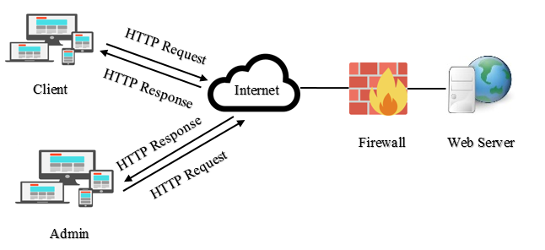

Figure 54: Network Topology

A network topology is the arrangement of a network, including its nodes and connecting lines. There are two ways of defining network geometry: the physical topology and the logical (or signal) topology.

**Development/ Construction/Build Phase**

### Technology Stack Diagram

It shows the set of software that provides the infrastructure of the capstone project which is composed of a full – stack JavaScript code and library. The components inside the technology that was used for the development of the web and mobile application are all from Meteor Framework Technology

**Technology Stack for LeavesHero:** A Web and Mobile-based app for Employee Leave Management

Figure 55: Technology Stack Diagram

#### **Software Specification**

The tables show the list of requirements that was being used during the implementation and the software deployment of the capstone project.

Table 23

DEVELOPMENT FOR WEB APPLICATION

|  |  |
| --- | --- |
| * Operating System | * Windows |
| * Test Editor | * Sublime Text 3 * Notepad++ |
| * Web Browser | * Google Chrome , Safari or Firefox |
| * JavaScript Framework | * Meteor |
| * Database | * PhpMyAdmin |

Table 24

DEVELOPMENT FOR MOBILE APPLICATION

|  |  |
| --- | --- |
| Android Software Development Kit |  |
| * JavaScript Framework | * Meteor |
| * Database | * PhpMyAdmin |

Table 25

DEPLOYMENT FOR WEB APPLICATION

|  |  |
| --- | --- |
| * Operating System | * Windows |
| * Web Browser | * Google Chrome , Safari or Firefox |

Table 26

DEPLOYMENT FOR MOBILE APPLICATION

|  |  |
| --- | --- |
| * Android OS | * Jelly Beans Version 4.1 and above |

#### **Hardware Specification**

Table 25 shows the list of requirements that was used for the hardware deployment of the capstone project.

Table 27

HARDWARE DEPLOYMENT FOR WEB AND MOBILE APPLICATION

|  |  |
| --- | --- |
| * Screen Display | Small Devices(Mobiles and Tablets)   * 768px and up   Medium Devices(Desktop)Large   * 992px and up   Devices(Large Desktop)   * 1200px and up |
| * Processor | * Pentium 4 or Multi-core processor |
| * Memory | * A least 1GB RAM or higher |
| * Hard Disk | * A least 10GB |
| * Internet Connectivity | * At least 1MBps or higher |
| * Mobile Devices Memory | * 500MB of RAM   (At least 600MB of free space or higher) |

### Program Specification

A Program Specification is what a computer program is expected to do. It can be informal; in which case, can be considered as a blueprint or user manual from a developer’s point of view, or formal, in which case, has a definite meaning defined in mathematical or programmatic terms.

#### **List of Modules**

Table 28

LIST OF MODULES

|  |  |  |  |  |
| --- | --- | --- | --- | --- |
| Programmer | Modules | HR/Company Owner (Admin) | Employee  (User) | SuperAdmin |
| Shaira Mae Romeo | **Subscription Management** |  |  |  |
| 1. Apply | **\*** |  |  |
| 1. Update |  |  | **\*** |
| 1. Delete/Cancel |  |  | **\*** |
| |  |  |  |  | | --- | --- | --- | --- | | No. of Points *(1 point per module per user)* |  |  |  | | | | | |
| Shaira Mae Romeo | **Account Registration Management** |  |  |  |
| 1. Create | **\*** |  |  |
| 1. Retrieve | **\*** |  |  |
| 1. Update | **\*** | **\*** |  |
| 1. Delete/Deactivate | **\*** |  |  |
| No. of Points *(1 point per module per user)* | | **1** | **1** |  |
| Ailen M. Manalili | **Leave Application** |  |  |  |
| 1. Create |  | **\*** |  |
| 1. Retrieve |  | **\*** |  |
| 1. Update |  | **\*** |  |
| 1. Delete/ Cancel |  | **\*** |  |
| No. of Points *(1 point per module per user)* | | **1** | **1** |  |
| John Lawrence B. Briones | **Leave Approval** |  |  |  |
| 1. Grant | **\*** |  |  |
| 1. Reject | **\*** |  |  |
| No. of Points *(1 point per module per user)* | | **1** |  |  |
| Shaira Mae Romeo  Ailen M. Manalili  John Lawrence B. Briones | **Customization** |  |  |  |
| 1. Create | **\*** |  |  |
| 1. Retrieve | **\*** |  |  |
| 1. Update | **\*** |  |  |
| 1. Delete |  |  |  |
| No. of Points *(1 point per module per user)* | | **1** |  |  |
| Shaira Mae Romeo | **Payment Management** |  |  |  |
| 1. Create | **\*** |  | **\*** |
| 1. Retrieve/View | **\*** |  | **\*** |
| 1. Update | **\*** |  | **\*** |
| No. of Points *(1 point per module per user)* | | **1** |  | **1** |
| Shaira Mae Romeo | **Report Management** |  |  |  |
| 1. Retrieve/View | **\*** | **\*** | **\*** |
| No. of Points *(1 point per module per user)* | | **1** | **1** | **1** |
| John Lawrence Briones | **Holiday Management** |  |  |  |
| 1. Create | **\*** |  | **\*** |
| 1. Retrieve/View | **\*** | **\*** | **\*** |
| 1. Update | **\*** |  | **\*** |
| 1. Delete | **\*** |  | **\*** |
| No. of Points *(1 point per module per user)* | | **1** | **1** | **1** |
| Ailen M. Manalili | **Leave Balance** |  |  |  |
| 1. Retrieve/View | **\*** | **\*** |  |
| No. of Points *(1 point per module per user)* | | **1** | **1** |  |
| John Lawrence Briones | **History** |  |  |  |
| 1. Retrieve/Generate | **\*** | **\*** | **\*** |
| No. of Points *(1 point per module per user)* | | **1** | **1** | **1** |
| Shaira Mae Romeo | **Notification** |  |  |  |
| 1. Retrieve/Generate | **\*** | **\*** | **\*** |
| No. of Points *(1 point per module per user)* | | **1** | **1** | **1** |
| Number of Modules per User *(equals total no. of per user)* | | **11** | **7** | **6** |
| Total Number of Modules | | **24** | | |

# REFERENCES

**Books**

ABADIANO, MARK N. (2008). A human Resources Information System for The

University of Cebu, Cebu City

JUMAWID J.L. (2008). Human Resource Information System for University of Bohol

**Internet Source**

CHOUDHURY, N. (2005). A Proposed Leave Management System for Dutch – Bangla Bank

Limited. Retrieved from http://dspace.bracu.ac.bd/xmlui/bitstream/handle/10361/28/A%20proposed%20leave%20management%20system%20for%20Dutch%20Bangla.pdf;sequence=1

DISSELKAMP L. (2013). Workforce Asset Management Book of Knowledge, 103. Retrieve

from https://books.google.com.ph/books?id=3hPRpLaXwg8C&pg=PA103&dq=leave+management+problems&hl=en&sa=X&ved=0ahUKEwixoZiuw_rcAhUNOSsKHRh5ARQQ6AEIMDAC#v=onepage&q=leave%20management%20problems&f=false ()

ESTANGLE, E. (2017). Top 3 Leave Management Problems of Business. Retrieved from

https://www.tanda.co/top-3-leave-management-problems-businesses/

MAHBUBDIIT. (2017). Employee Leave Management. Retrieved from

https://www.slideshare.net/mahbubdiit/employee-leave-management-system

MAHOREY, P. (2012). Leave Management System (Master’s Thesis). Retrieved from

https://www.slideshare.net/pratikmahorey/leave-management-system-15373132

WAHAB A. (2010). Agent Technology Approach to Improve KUIM Leave Management

System (Master’s Thesis). Retrieved from http://eprints.utem.edu.my/13832/1/Agent_Technology_Approach_To_Improve_KUIM_Leave_Management_System_-_24_Pages.pdf

# CURRICULUM VITAE

**HUSTLER**

**John Lawrence B. Briones**

Address : 18-81 Green Hills, Capitol Site, Cebu City

Mobile No. : 09491917722

Email Address: [Djlawrence1997@gmail.com](mailto:Djlawrence1997@gmail.com)

**Personal Information**

Gender : Male

Age : 20

Birth Date : November 21, 1997

Birth Place : Cebu City

Religion : Roman Catholic

Civil Status : Single

Name of Mother : Analesa B. Briones

Name of Father : Renato B. Briones

Language/ Dialect Spoken : English, Tagalog, Bisaya

**Educational Background**

College : University of Cebu – Main Campus

Course : Bachelor of Science in Information Technology

Location : Sanciangko St., Cebu City

Year Attended : 2015 – Present

School : Abellana National School

Location : Osmeña Blvd, Cebu City, Cebu

Year Attended : 2011 - 2015

School : Kamputhaw Elementary School

Location : 15 N Escario St, Cebu City, 6000 Cebu

Year Attended : 2004 - 2010

**HACKER**

**Shaira Mae Romeo**

Address : Sitio Manga, Tisa, Labangon Cebu City

Mobile No. : 0933 968 1041

Email Address: romeoshairamae@gmail.com

**Personal Information**

Gender : Female

Age : 21

Birth Date : December 17, 1996

Birth Place : Cebu City

Religion : Roman Catholic

Civil Status : Single

Name of Mother : Rufina R. Guradillo

Name of Father : Jose Rexon C. Guradillo

Language/ Dialect Spoken : English, Tagalog, Bisaya

**Educational Background**

College : University of kCebu – Main Campus

Course : Bachelor of Science in Information Technology

Location : Sanciangko St., Cebu City

Year Attended : 2015 – Present

College : Britech College

Course : Associate in Computer Technology

Location : Angelica Bldg., Osmeña Blvd Cebu City

Year Attended : 2014 - 2016

School : Dalaguete National High School

Location : Poblacion Dalaguete Cebu

Year Attended : 2010 – 2014

School : Dalaguete Central Elementary School

Location : Poblacion Dalaguete Cebu

Year Attended : 2003 - 2010

**HIPSTER**

**Ailen M. Manalili**

Address : Guadalupe, Cebu City

Mobile No. : 0908 181 5837

Email Address: [manaliliailen498@gmail.com](mailto:manaliliailen498@gmail.com)

**Personal Information**

Gender : Female

Age : 20

Birth Date : April 4, 1998

Birth Place : Cebu City

Religion : Roman Catholic

Civil Status : Single

Name of Mother : Annabelle M. Manalili

Name of Father : Necias P. Manalili

Language/ Dialect Spoken : English, Tagalog, Bisaya

**Educational Background**

College : University of Cebu – Main Campus

Course : Bachelor of Science in Information Technology

Location : Sanciangko St., Cebu City

Year Attended : 2016 – Present

College : Britech College

Course : Associate in Computer Technology

Location : Angelica Bldg., Osmeña Blvd Cebu City

Year Attended : 2014 - 2016

School : Ramon Duterte Memorial National High School

Location : V. Rama Avenue Guadalupe Cebu City

Year Attended : 2011 - 2014

School : Mar and Dorie Darunday National High School

Location : Managase, Borbon Cebu

Year Attended : 2010 – 2011

School : Guadalupe Elementary School

Location : V. Rama Avenue Guadalupe Cebu City

Year Attended : 2004 - 2010

# APPENDICES

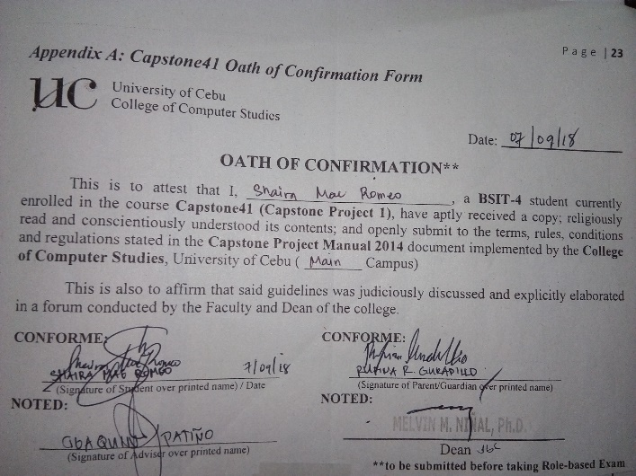

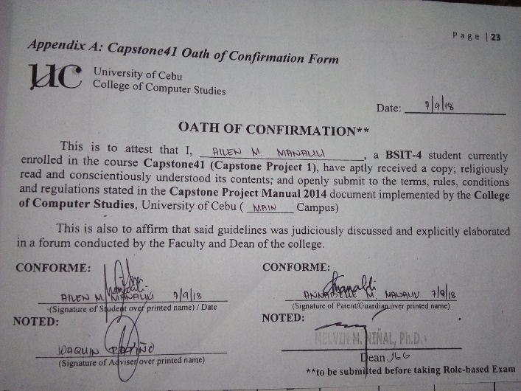

Figure 56: Appendix A: Oath of Confirmation Form

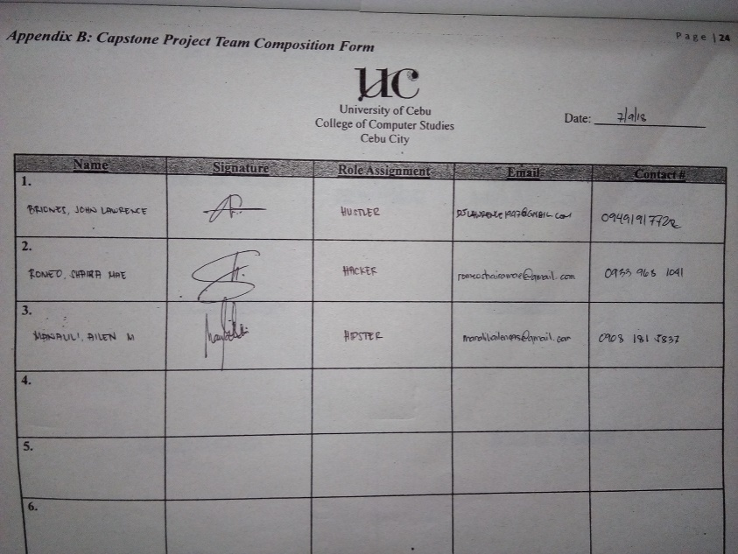

Figure 57: Appendix B: Capstone Project Team Composition Form

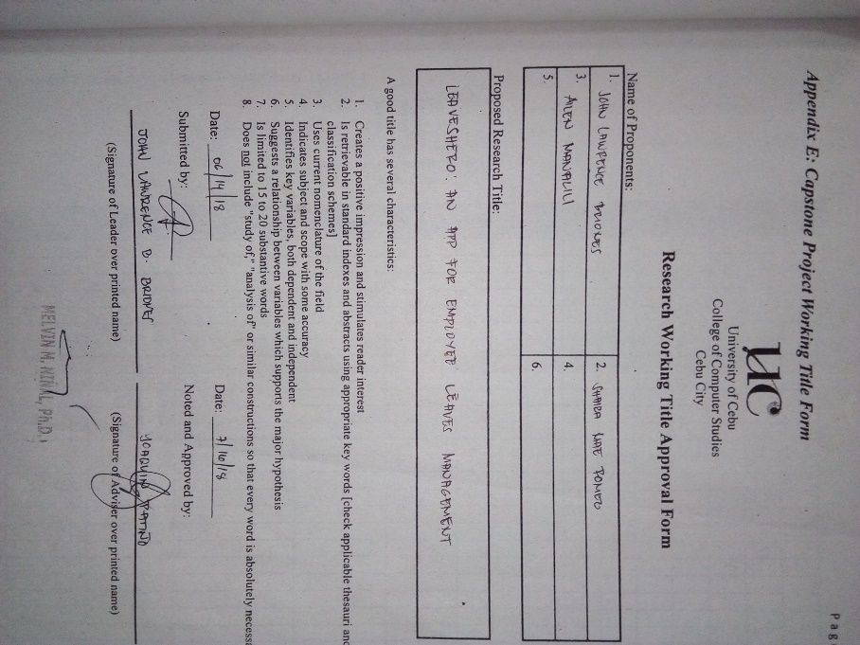

Figure 58:Appendix E: Capstone Project Working Title Form

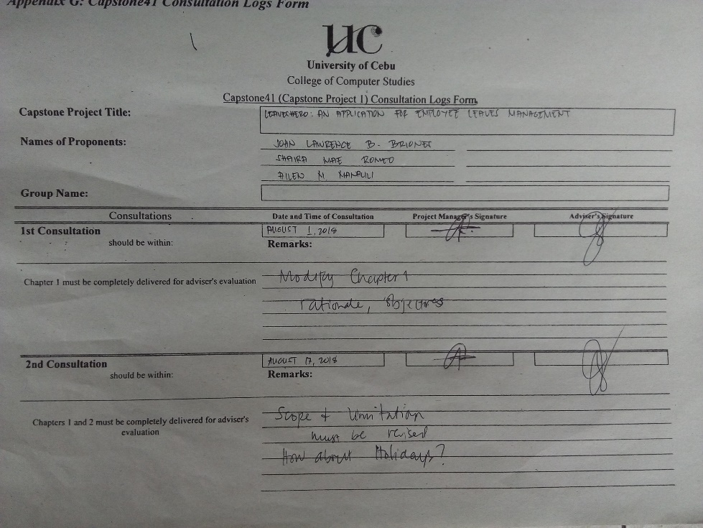

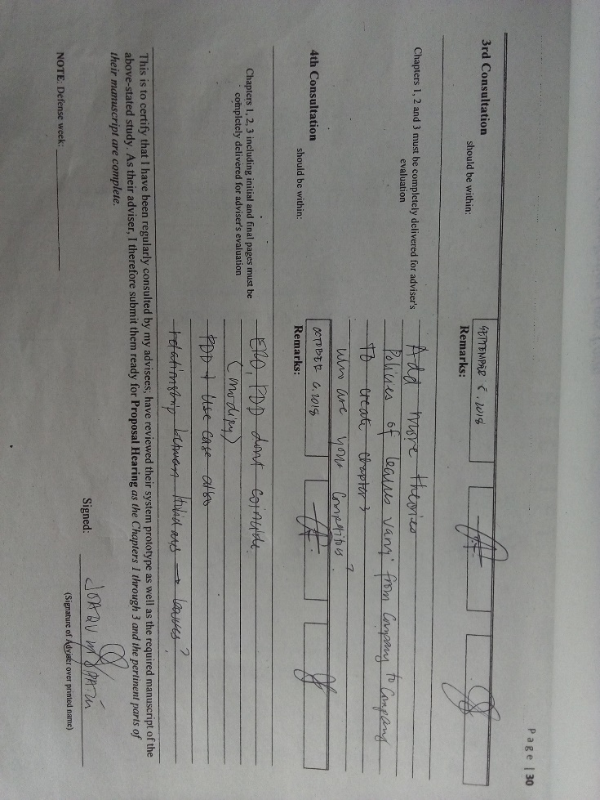

Figure 59 : Appendix G: Capstone 41 Consultation Logs Form

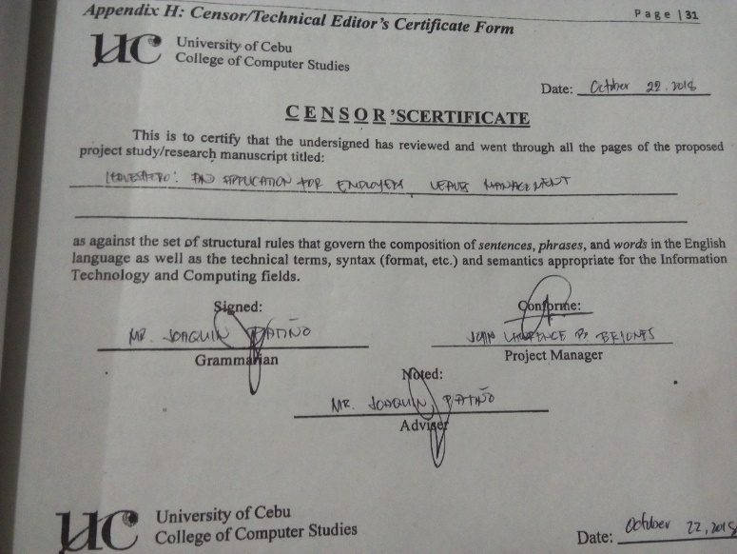

Figure 60: Appendix H: Censor/Technical Editor's Certificate Form

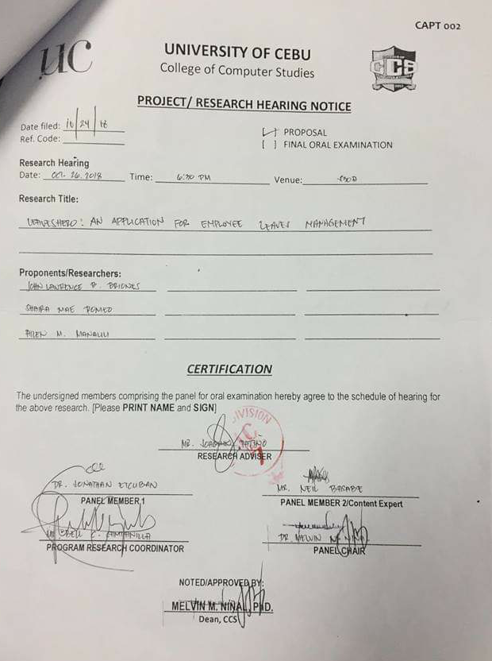

Figure 61: Appendix L: Capstone Project Hearing Notice Form

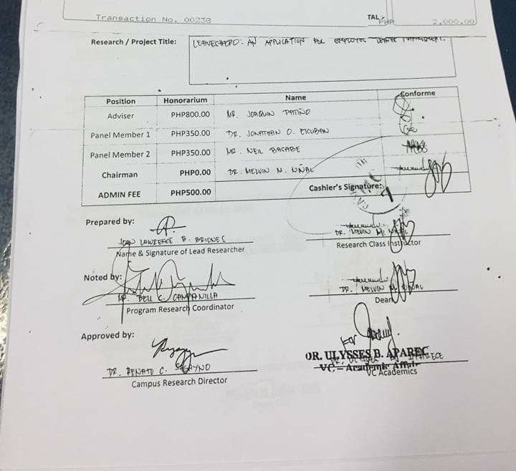

Figure 62: Appendix M: Capstone Project Panel Honoraria (Form 10)